

On-board Multi-Effects Guitar Pedal

Third Year Individual Project – Final Report

May 2022

**Harry Moss**

10478272

Supervisor: Dr P Gaydecki

Contents

1. Project Overview 1

1.1. Abstract 1

1.2. Background and Motivation 1

1.3. Aims & Objectives 3

1.4. Existing Solutions 4

1.5. Target Market Research 10

1.5.1. Peer Review 1 – Research 12

2. Theory & Design 13

2.1. Theoretical Development 13

2.1.1. Distortion 14

2.1.2. Gain/Boost/Fuzz 16

2.1.3. Echo 16

2.1.4. Reverb 18

2.1.5. Performance Test 19

2.2. Program, Circuit and Housing Design 22

3. Project Development 25

3.1. Project Method 25

3.2. Program Development 26

3.2.1. Peer Review 2 – Program 29

3.3. Circuit Development 30

3.4. Housing Development 30

4. Results 31

4.1. Overview of Results & Discussion 31

4.2. Analysis 32

4.2.2. Peer review 3 – Analysis 33

5. Conclusion 34

6. References 35

7. Appendices 40

7.1. Appendix 1 – Project Timeline 40

7.2. Appendix 2 – Schematic Diagrams 43

43

7.3. Appendix 3 – Housing Development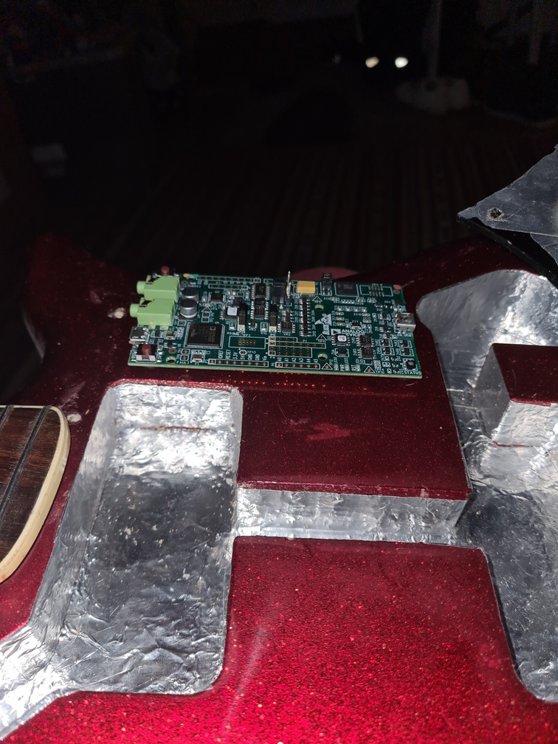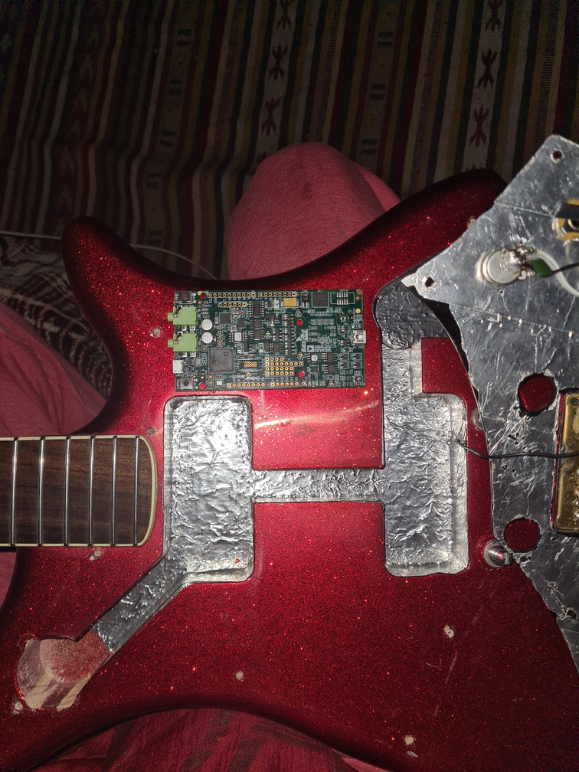 45

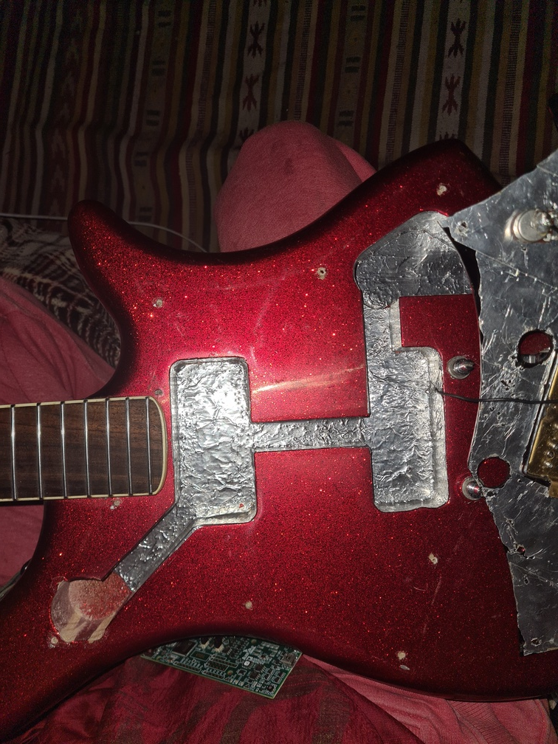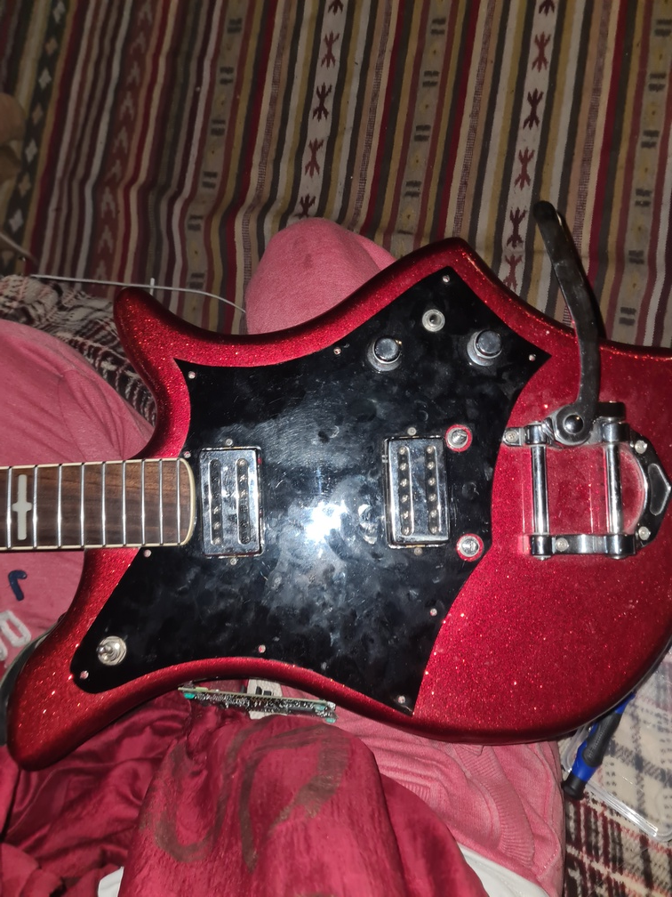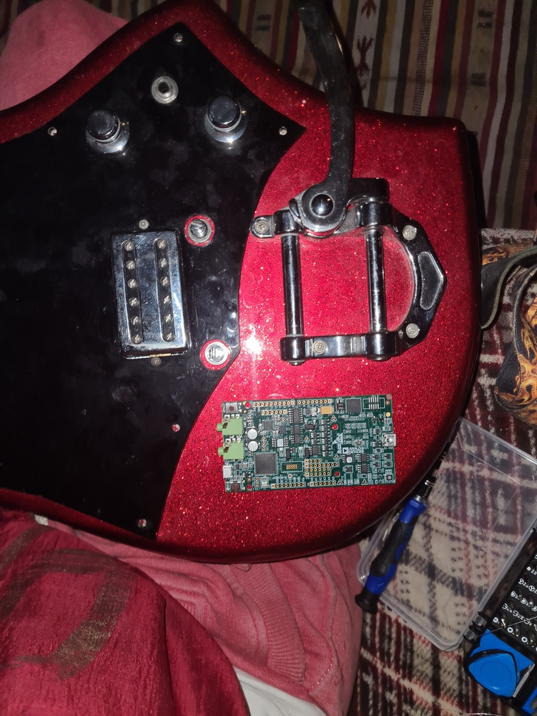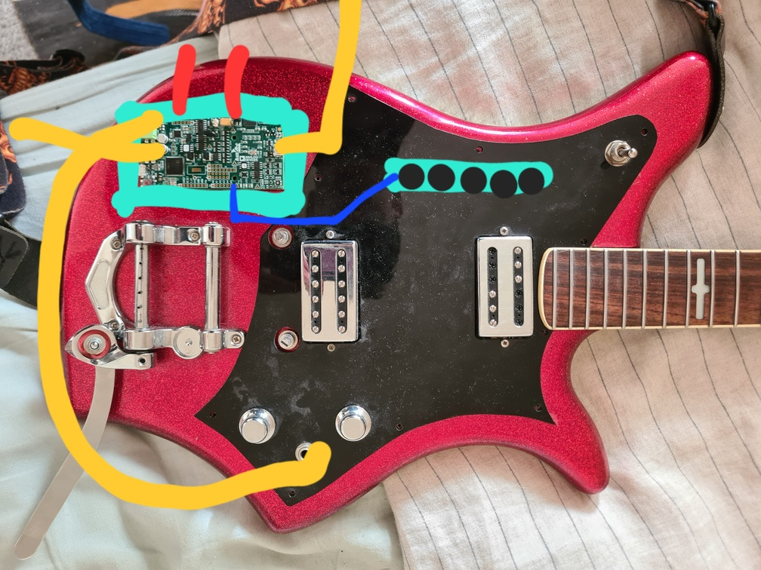 46

7.4. Appendix 4 – Program Code (Full) 49

7.5. Appendix 5 – Circuit Construction 62

7.6. Appendix 6 – Housing Construction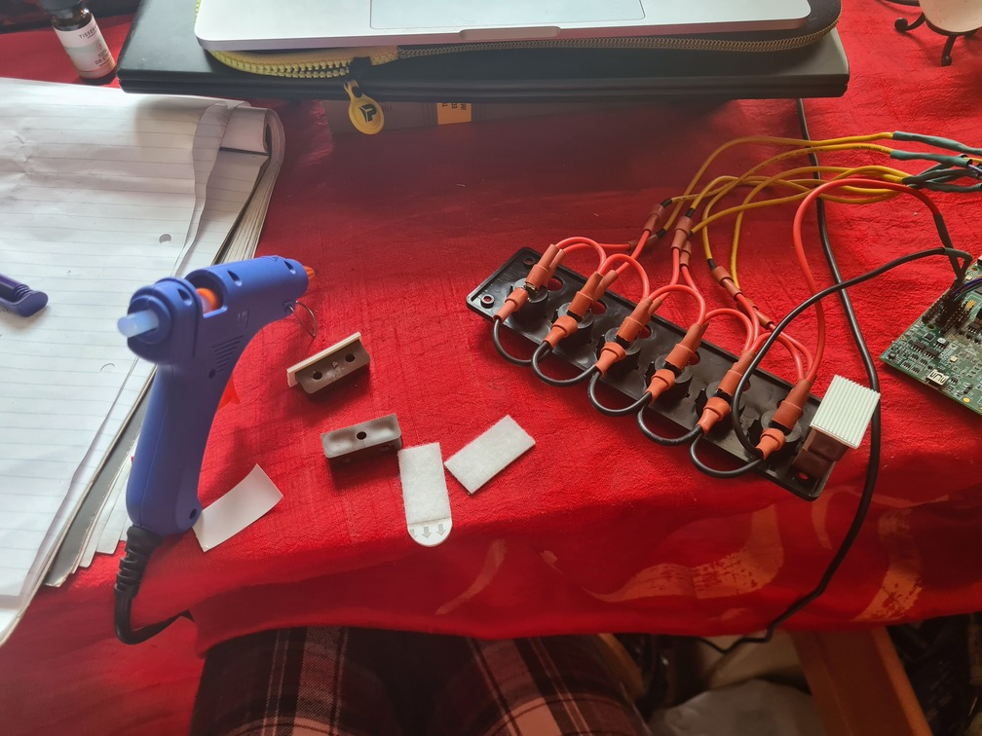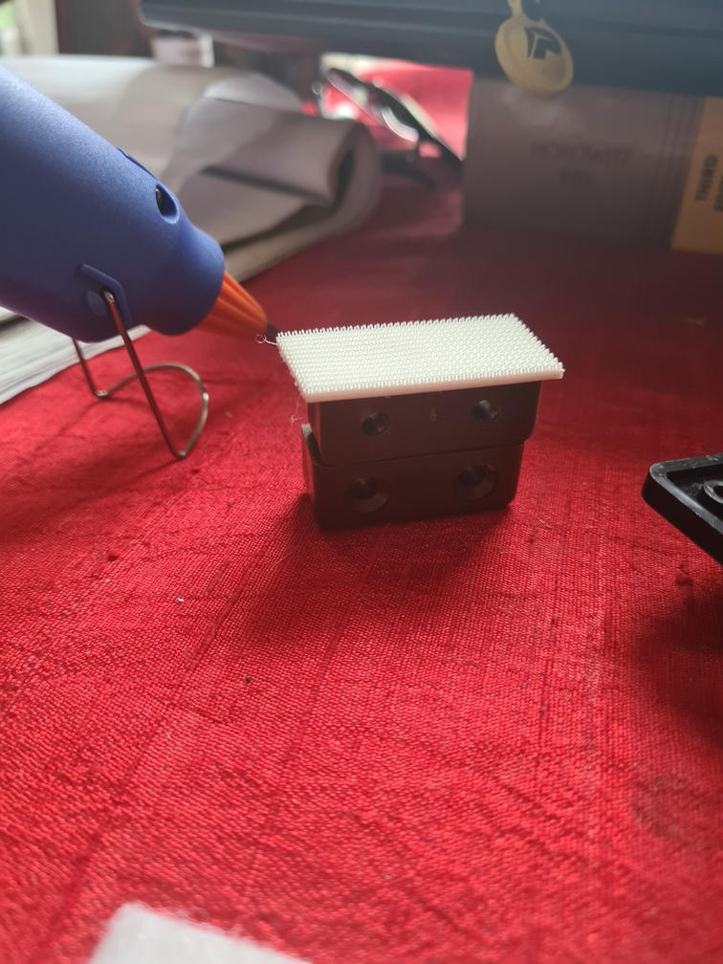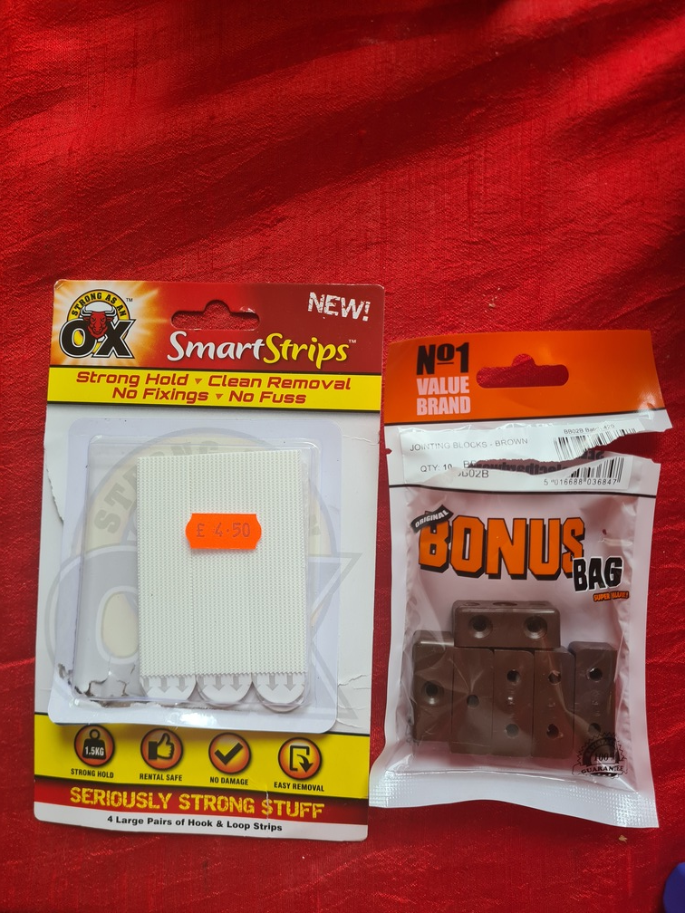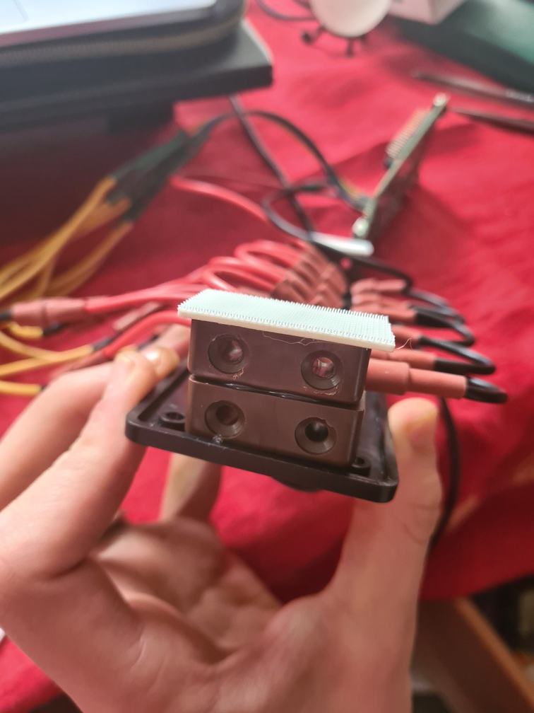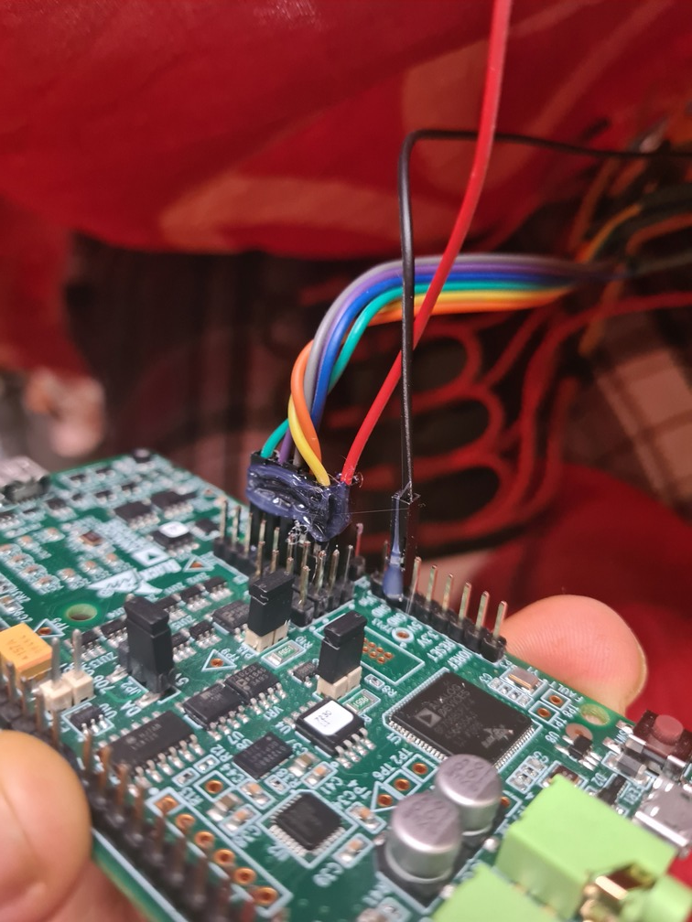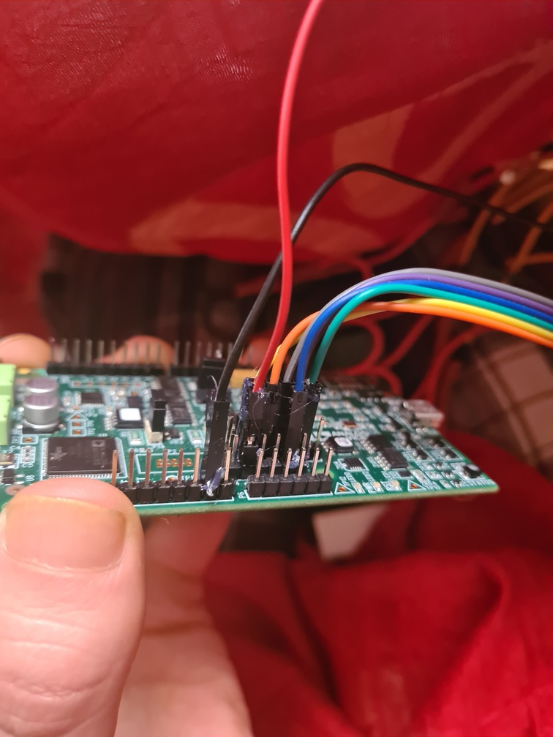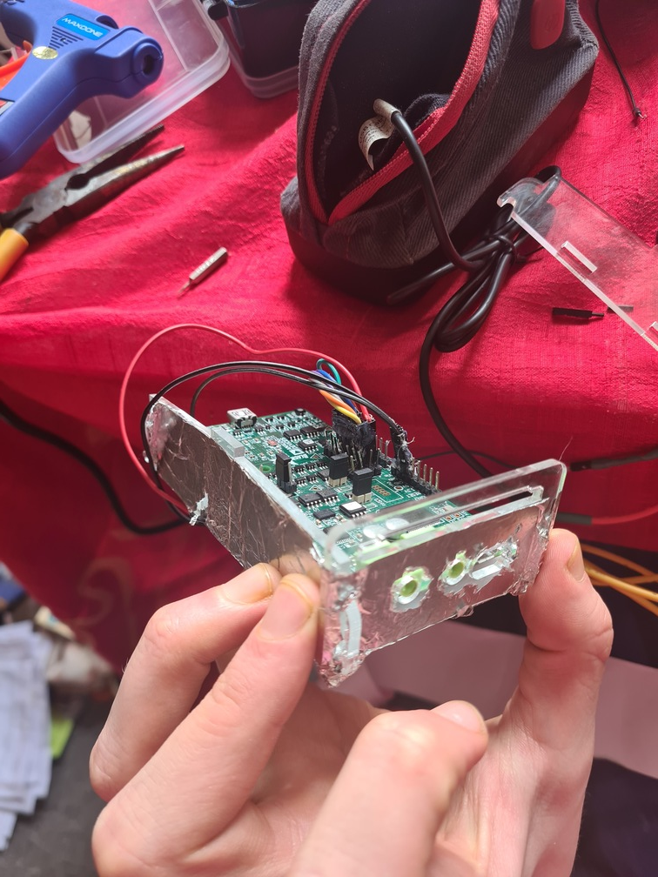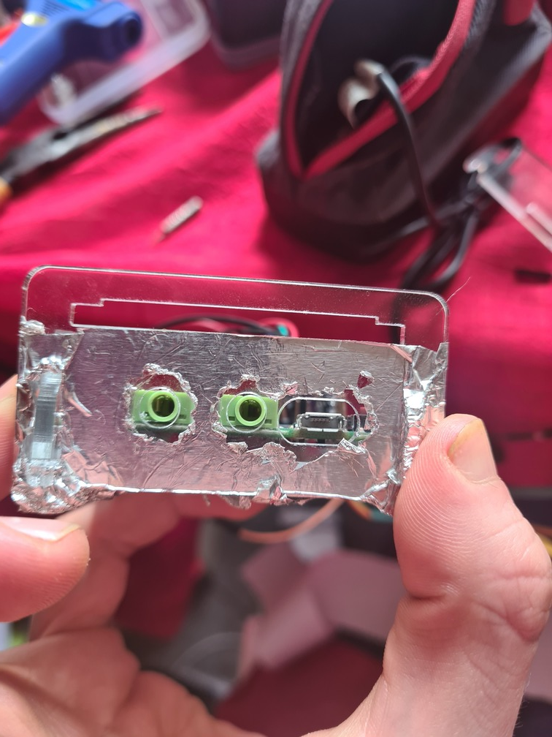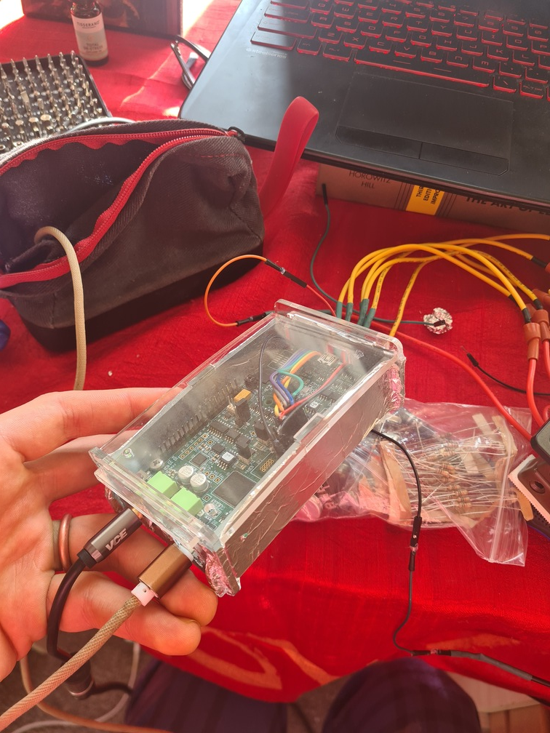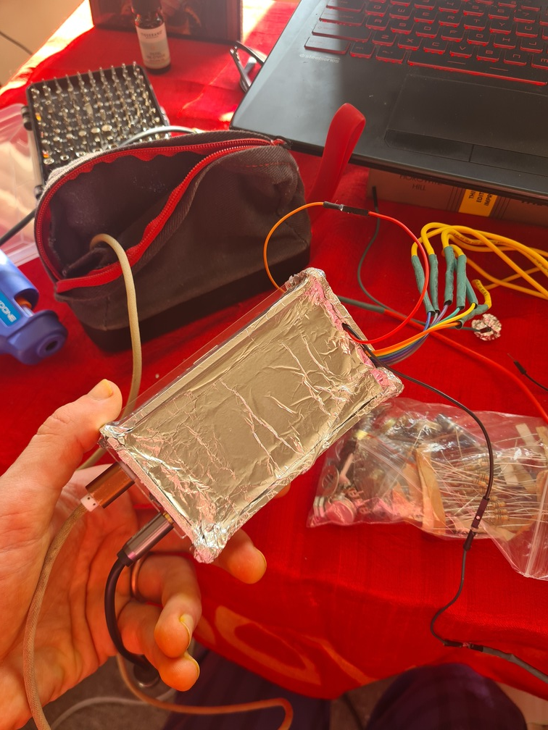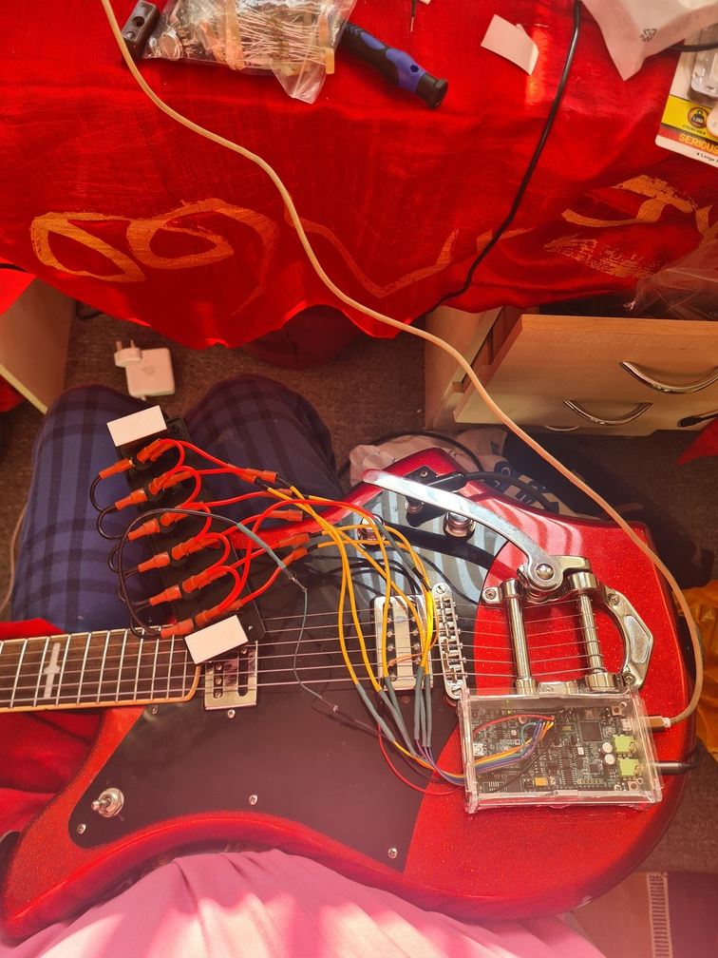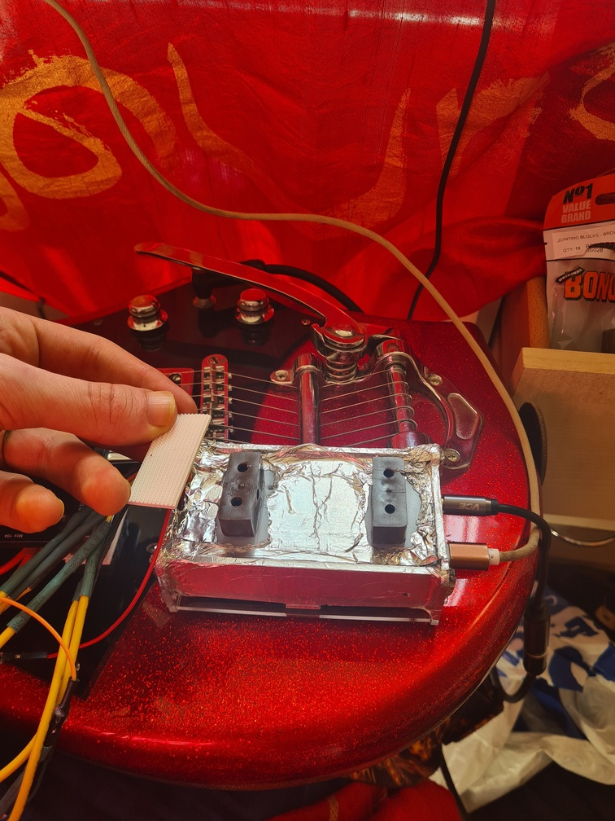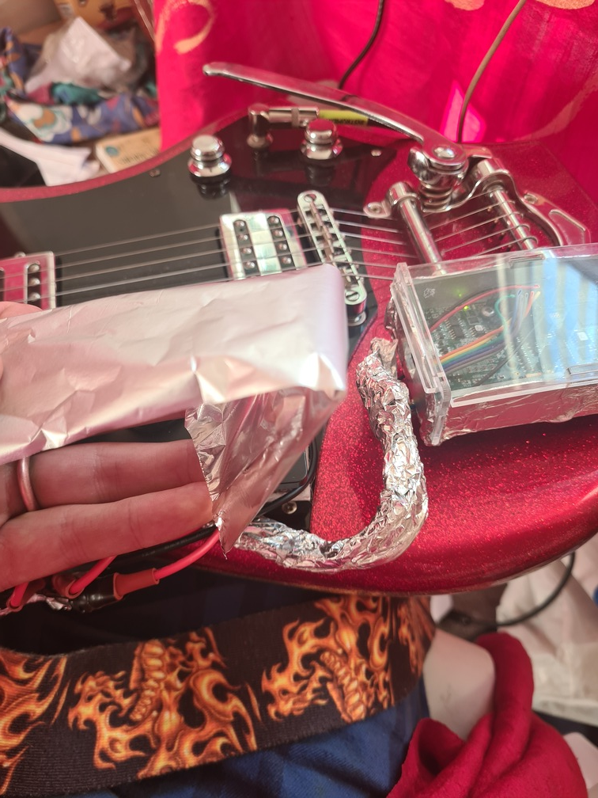 67

7.7. Appendix 7 – Finished Product Photos 79

7.8. Appendix 8 – Peer Review 3 83

7.8.1. Jonathan 83

7.8.2. Fraser 86

Total word count: 10429

# Project Overview

## Abstract

This report consists of the progression of build of a real-time DSP system that acts as a portable, hand-operated *onboard* guitar pedal. The project ends with a success, with the outcome of a fully functional multi-effects pedal consisting of 4 different effects, with minor adjustments made along the way. The end product fulfilled 5 out of the 6 aims as listed in the beginning, and, with minimal housing adjustments, could be made into a successful commercial product. The design methodologies and development stages are split amongst 3 categories: program, circuit and housing – with full code, flowchart and schematic diagrams listed in the appendices at their relevant points. The writer of this document hopes the reader has a pleasant reading experience.

## Background and Motivation

Currently, in the world of guitar musical effects, the most populated and well-established form of signal manipulation involves the use of an external, grounded foot-switch – most prominently perhaps in a live setting, outside of the musical studio. There are a huge number of different effects available on the market today, ranging from simple battery-powered reverb pedals to state-of-the-art, mains-fed loop station pedal boards [1] to transform a guitarist’s, bass guitarist’s, and even a curious keyboard player’s stage presence to a completely different level.

So what is the issue here? There is no issue exactly – it is simply a question of efficiency. It is not a new concept that various manufacturers have taken their approach of an all-in-one multi-effects pedal to market before – the *Line 6 Firehawk FX* pedalboard offers the player an enormous multitude of effects that can be programmed (in a high-level format for user-friendliness) directly from a free app that is downloadable after purchase [2]. There is even an option to engage in an online community, where other users of the *Firehawk* can save and upload their own programmed guitar/bass ‘presets’ for one to download onto their own *Firehawk*. The range of effects is enormous with this sytem, and it does a good job of condensing multiple effects into one package; but what about in a stage setting? There is only one major problem, space.

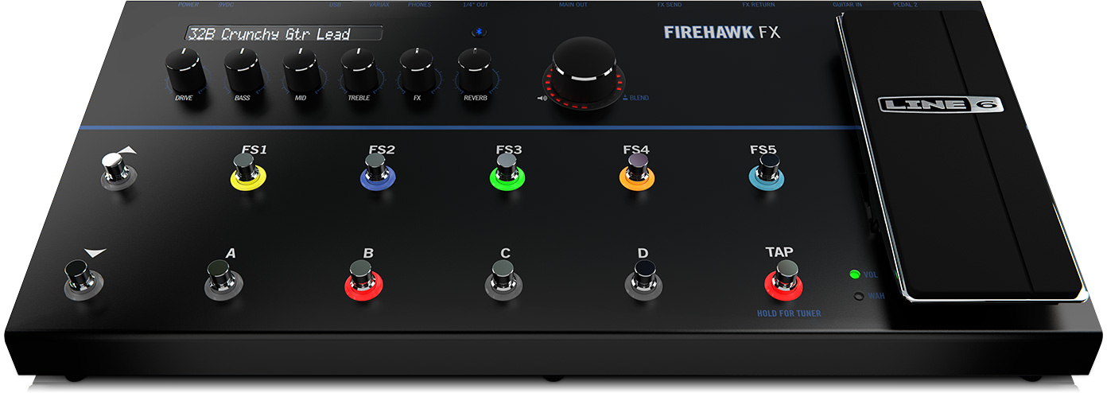

Figure 1 [3]

As seen in Figure 1, the *Firehawk* is roughly ½ metre long and ¼ metre wide, weighing just under 6.4 kg (not to mention a case that weighs ~1 kg extra) which is not uncommon amongst other multi-effects pedal systems already on the market, showing that a package like this one really comes at a cost – not to mention its £348 price tag! [4] With all the other equipment that an electric guitarist/bassist would becarrying already (amplifiers/cables/instruments) to and from a performance, there is little room to add in many more *desirable* as opposed to *essential* items such as these; they would rather limit themselves to a few small footswitches they could carry in their jacket pockets along with their eye shadow and flares.

These constraints are the motivation behind this project. A symbiotic, multi-effects, but most importantly – *on-board* guitar pedal. This system will, upon completion, sit not on the floor, but at the guitar end of the cable. Along with several toggle switches to offer additional functionalities, the device will bypass the ¼ inch input jack that a guitarist would be used to plugging a cable into; instead it will feed through into a dedicated real-time DSP system, before sending the signal back to the amplifier/sound system.

There is a real incentive for a wild, stage-loving musician to purchase a system as proposed in this report – there is no longer a requirement to be stationary and standing next to a foot-pedal to switch effect mid-performance. So long as they were using a radio-controlled I/O jack (which are very widely available in every music store), a guitarist could in theory run around, enter a mosh pit, or even crowd surf for a whole set knowing that he/she has full, real-time control over the sound of their instrument.

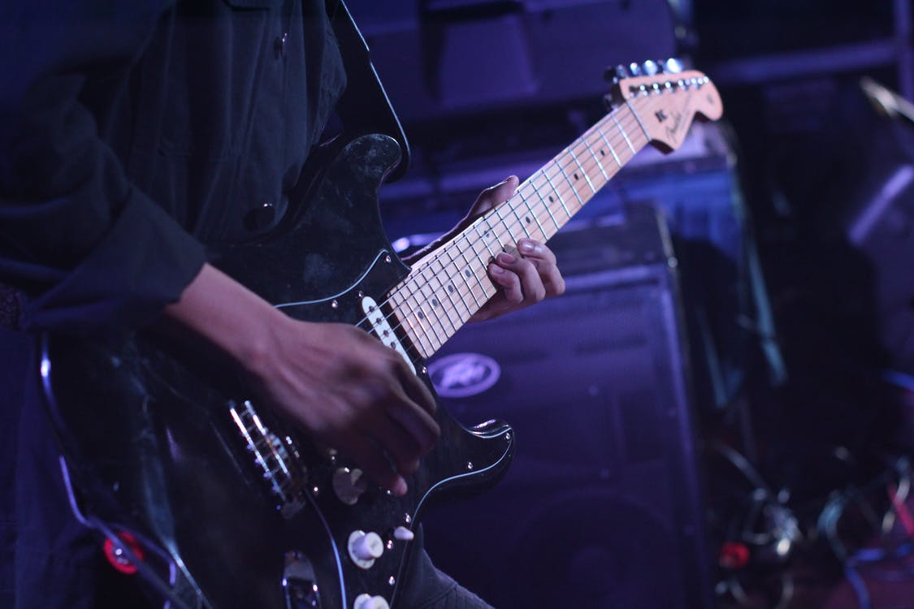

Figure 2 [5]

Thanks to the *Line 6’s Firehawk Remote* app, it appears adding in Bluetooth functionality would be an attractive proposition for this project. However, it only takes a 2 minute search on the *Google Play* store to discover this same app has many poor reviews – specifically buggy behaviour due to *Line 6* failing to keep up with OS system changes on Android. Due to this added complexity post-production, the focus for this project will be on the points covered previously; i.e. a commercially viable product with high-quality effects.

Nonetheless, having the ability for the user to model the effects to his/her preference would attract a huge variety of musicians, and shall therefore be added into the list of overall Aims & Objectives of this project below.

## Aims & Objectives

The following is a list of Aims and Objectives for this project. These have been decided based on the motivations of a musician focused on live performances, along with which gaps needing to be filled before ending up with a commercially viable product.

1. **Identify any further requirements needed for an electric guitarist/bassist in a live performance setting:** this can be realised by interviewing other players of guitars and basses and asking them about their thoughts and opinions of the current situation involving multi-effects music pedals.

2. **Identify and solve any problems in fitting the device on the guitar:** the pedal will either be internally or externally mounted on the guitar, and thus market research/peer review must be carried out for the best option. Manufacturing costs will be considered here (e.g. cost of creating a modified scratchpad to make way for components etc.) and kept at a minimum.

3. **Derive a working system allowing the user to adjust/reprogram the on-board effects:** as with the FIrehawk earlier, Bluetooth is an option – care must be taken with OS updates, especially if in mobile app format. Wireless connectivity ensure the guitarist is still able to move around freely (i.e., not tethered to any fixed wires/cables) and also be a user-friendly method of switching out undesirable effects or changing the tone of current effects at the touch of a button.

4. **Identify the most suitable DSP platform for the project:** a number of different options for the main Signal Processing chip will be analysed when Existing Solutions are analysed. During Theoretical Development, the performance metrics of these chips will be compared, with considerations also given to their cost, power consumption and size (which could influence where the system will be mounted).

5. **Quantify the number of external control switches needed:** collaboration with other musicians (Peer Review 1) and their personal preferences will ensure this gets reliably established. Market Research will also be used to conclude this Aim, which should be established once the Circuit Design section is finished.

6. **Identify the 5 most important musical guitar effects (in order of preference) as a foundation for the project:** further market research will be carried out online into what electric guitarists (the target market) as a whole feel are the most important effects, along with considerations of programming complexity in order to manage the timeframe of this project. The method will be to realise the most popular and preferred effect in a stable, working manner first and foremost, then to implement the other effects in order of importance if the project has successfully hit milestones on schedule and created leeway for sound exploration.

Now that there is an established list of Aims & Objectives, an official ‘Project Timeline’ can be found in **Appendix 1**, which shall form the basis of time-management in this project.

## Existing Solutions

The aim of this section is now to represent an altered version of a traditional literature review. This project proposal is quite unique; there are very few existing examples online to draw upon and use as both inspiration and technical development, and there are certainly no academic papers that have been ambitious enough to target the electronic/programming architecture within an *internalised* digital guitar pedal.

However, there are a suitable number of *hobbyist* solutions on the likes of *Youtube* that can help facilitate a push-start for this project. Certain Aims such as 2, 3 and 4 will be well covered during the analysis of the following pedals, and will allow the remaining aims to be covered by research findings shortly. A more in-depth technical analysis for how the guitar effects will be constructed will come later in Theoretical Development.

Solution 1: Raspberry Pi Zero Guitar Pedal

The first solution, the *Pedal Pi*, is likely the most market-ready option on the list – the UK-based opensource company *ElectroSmash* released this solution to how a DSP system could be powered using a *Raspberry Pi Zero W*, of which, out of all the *Raspberry Pis*, is the smallest and most compact; a very desirable feature for this project[6][7].

To tell the truth, the sound quality is fairly mediocre [8]. The response is much clearer than another product by *Electrosmash,* the *PedalShield Uno* (the same reviewer also did a video on this in [9]), given that this *PedalShield* is constrained with the much weaker processing power of the *Arduino Uno*, however, the *PedalPi* still runs into issues when more processor-intensive effects are introduced – the reverb (perhaps one of the most wide-spread effects in the entire music industry) comes out more like a low-gain distortion than an actual range of echoes, likely due to the fact that this kit runs a 12 bit ADC-DAC Knowing this, the *Raspberry Pi Zero W* will be one of the chips that will need to face the metrics test during the Theoretical Development section before making a firm decision.

The one major disadvantage of this product is the fact that it is not an *onboard* guitar pedal, and therefore not fulfilling one of the major requirements for allowing the user to be mobile during a live setting. However, given the nature of this being opensource (full board schematics and working C code is available on the *ElectroSmash* website [10]), there is a possibility with the *Pi Zero* to fulfil Aim 2 and 4 by giving a more compact (the chip has dimensions of only 65mm × 30mm [7]) and easily mountable PCB with altered control functionality. The *Pi* also comes with a built-in Bluetooth module, and, given its huge popularity all over the world, a wealth of online support on the *Raspbian* OS that could mean the difference between being able to offer reprogramming effects via a mobile app off-line, as in Aim 3. This will again be explored further during Theoretical Development.

|  |  |
| --- | --- |
| Pros | Cons |
| Usage of the *Raspberry Pi Zero W* with a redesigned PCB could increase compactness and extend control functionality (as in Aim 5). | Too large to be mounted directly on the guitar. |
| Bluetooth functionality built-in for possibility of wireless off-line app usage. | Mediocre sound quality. |
| Lots of online guides for this system to speed up project development and more reliable post-production support. | Limited with operating varieties of real-time effects simultaneously. |
| Already an established product – immediately capable of mass production. |  |
| Reasonably cheap (only $49.95 + $15 for the *Pi Zero* at selling prices [10][7]). |  |

Solution 2: NeuralPi Guitar Pedal

This next solution, whilst still being powered by a *Raspberry Pi*, has a more refined output than the previous example [11]. This is due to the presence of a specialised *HiFi Berry* soundcard, of which, if one is to visit the datasheet, it is obvious why there is an upgrade; the card uses a dedicated 192kHz 24 bit ADC-DAC, which is double the number of bits of the *PedalPi* [12]. There is also a specialised audio OS (namely *Elk Audio*) that further contributes to an overall improvement in sound quality, which is an indication that if a high-quality DSP system is going to be realised (Aim 4) which can still handle the processing power of multiple effects working in tandem simultaneously, it may demand a specialised software platform that would making off-line editing of effects for the user tricky (Aim 3), as the urgency of an online community is not necessarily there to constantly update their software as soon as the big mobile OS systems (*Android, Apple*) update theirs.

Aside from the bulky components in this project (which would inevitably make it unsuitable as a finalised product), the only other disadvantage from the video review is that it is unclear as to how this system would perform when tasked with operating many effects (Aim 6) simultaneously – as far as the sound goes, it does an excellent job of recreating the sound of a TS9 guitar pedal along with adding reverb and delay, but it is unclear as to how well it might do when flange or chorus are also stringed into the signal output. In addition, it is important to note that the main DSP system for this is not the *Pi Zero*, but the *Pi 3* instead, which comes with an advantage – the *Pi 3* not only is 20% faster than the *Pi Zero* in CPU clock rate, but it is also quad-core, as opposed to the *Zero’s* single-core [13].

Although it seems tempting to jump towards the more powerful *Pi 3* for fulfilling Aim 4, the compactness of this end product is crucial, as the system will be mounted either inside the pickguard or in a free spot on the guitar body. With dimensions of 85mm x 56mm x 17mm (Figure 3 right), the *Raspberry Pi 3* series would likely offer more trouble than benefit for achieving a commercially viable product (many guitars have limited space to accommodate even this size), and thus the focus on the performance metrics test in Theoretical Development will only be on the *Pi Zero* (Figure 3 left) [14].

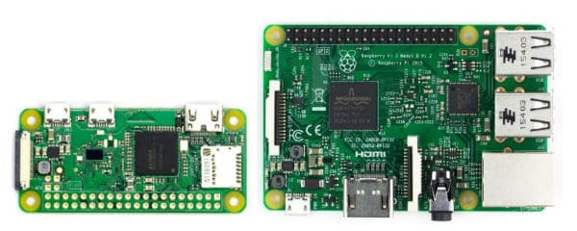

Figure 3 [14]

|  |  |
| --- | --- |
| Pros | Cons |
| Overall sound quality is good. | Too large to be mounted on the guitar (bulky components are present e.g., soundcard and extra cables) |
| System is able to handle 3 very important guitar musical effects (distortion, reverb and delay) with ease. | Post-production support may be limited (requires specialised software) |
|  | Fairly expensive (hardware alone costs $100 plus additional cables etc. [11]). |
|  | Uses the *Raspberry Pi 3* which is both larger and more expensive compared to the *Pi Zero* counterpart seen in solution 1. |

Solution 3: Internal Guitar Ring Modulator

Perhaps the most distinct example on this list, a *hobbyist* creator named Andrew Sink created a fully internalised (the first of its kind in in this Existing Solutions section) guitar ring modulator effect [15]. This effect is widely used in fields of DSP, with perhaps the most famous usage being in an analogue format (via a 30 Hz modulating sine wave recorded onto a tape machine then a microphone as the carrier wave) to create the iconic voices of the *Cybermen* and *The Daleks* in *Dr Who* [16].

After watching and listening to the video review available on Sink’s website, it would be wrong to say that the *onboard* pedal is non-unique, and certainly proves that it is possible to manifest a fully internalised guitar pedal into reality. However, the sound of this specific ring modulator effect is something that may only appeal to a certain (perhaps more *hipster*) group of musicians, with some sitting back and admiring the unfolding of sound exploration before them, and others feeling obligated to run as far away from their headphones in sheer terror (the writer of this document was the latter) – it is easy to see why this effect is generally restricted only to synthesisers within the world of music.

Analysing the signal quality, there appears to be a feedback issue when mounting inside the guitar – this would be desirable for the *AC/DC* distortion-lovers (along with *Jimi Hendrix-influenced* guitar players who want to make use of the feedback ‘screech’), however, this is a big problem when cleaner effects such as reverb and delay are used, since the noise will be carried into the echo waveforms. Issues further arise when the system turns digital (Sink’s system here is limited to purely analogue), as the very high clock rates could potentially cause poor sound quality [1].

Having the pedal internalised comes with another caveat; players of expensive vintage electric guitars (e.g. older *Gibson Les Pauls*) who might want to resell their instrument could be displeased with the requirement of cutting and drilling their guitar to make way for a multi-effects pedal of this kind. However, since this is based on writer opinion, not on hard factual evidence, this will be explored next during Target Market Research.

|  |  |
| --- | --- |
| Pros | Cons |
| Product is fully internalised into the guitar. | Pleasantness of sound effect is questionable! |
| Low-power (a single 9V battery). | Sound quality issue of noise due to internal mounting (could become very significant when in the digital domain). |
| Very cheap to build and manufacture with minimal parts. | Drilling and/or cutting of guitar required due to internal mounting. |
|  | Restricted to pure analogue – very little leeway for a multi-effects pedal solution. |

Solution 4: C++ *SHARC* project

This solution leads into the most probable rival yet for the *Raspberry Pi Zero*, the *SHARC (Super Harvard ARChitecture*) processors contain specialiased DSP architecture, including features such as 32/40 bit floating-point math and 32 circular buffer support that is simply not feasible for the more general market-oriented chips that *ARM* are forced to adhere to when inside the (more standardised) *Raspberry Pi* range [17].

The result of this change of chip is strikingly obvious; the quality of sound produced by this project is without question the greatest seen in the 4 solutions so far, with almost no noise or jitter being heard at all [18]. All effects as present in the video review are audibly very clean, with even very large delays presented towards the end of the video being processed without any sign of signal degradation/loss; usage of a specialised DSP chip such as this one could be perfect for implementing all the important effects once Aim 6 is finalised, which would instigate a very market-ready product.

For drawbacks, this solution is more of a demonstration of a real-time DSP chip with the programmer’s skill with C++; it is not yet a market ready solution. Aims 3 and 4 demand that external controls are implemented so the user can move them as he/she wishes rather than instead simply adjusting the fixed, pre-soldered potentiometers (seen in the video), and, since there is no in-built Bluetooth functionality, it is likely that further wiring will be necessary. In addition, Aim 2 states that it is important to identify constraints of mounting on the guitar body, and dimensions are unavailable for this solution since it is unclear which model this chip is, but (it is visibly very bulky from the video however) [18]. In Theoretical Development, a more compact solution to this problem will be investigated.

|  |  |
| --- | --- |
| Pros | Cons |
| Sound quality is excellent. | Still too large to be mounted on the guitar – alternatives will come in Theoretical Development. |
| Little to no audible noise whatsoever. | Not yet a marketable product. Aims 3 and 4 demand external controls. |
| Handles multiple processor-intensive (compressor, delay and phaser) effects simultaneously in real-time with ease. |  |
| Potentially inexpensive – *SHARC* modules start at < $10, which may be all that is necessary for the purposes of this project [17]. |  |

## Target Market Research

As stated in the introduction, the sheer volume of different musical effects available for the guitar alone are staggering. There are, however, certain sounds which have stood the test of time since as far back as the 50s and are still the go-to choice for many guitarists across a multitude of genres – laid-back jazz to head-thumping heavy metal. In this section, the beginning of an analysis of which of these (specifically the top 5 in order of preference as directed by Aim 6) are most crucial for this guitar pedal project shall commence.

According to the *National Guitar Academy*, all effect types can be broadly grouped into 4 main categories [19]:

* Distortion – Overdrive, Boost/Gain and Fuzz.
* Modulation – Chorus, Phaser, Flange and Tremolo.
* Delay/Reverb
* Miscellaneous – Loopers, Octavers, Compressors and Wah-Wah pedals.

This is an excellent place to begin an online investigation, as it is now possible to spot any trends on whether or not certain effect categories are more *desirable* rather than *essential* to build a product that would generate success in the marketplace. Since it can be assumed that effects in the same group have a similar nature to one another (excluding the misc. category), prioritising an effect’s neighbour to be implemented alongside it will lead to greater efficiency during the programming stages that will follow shortly.

On a forum in *guitartricks.com* the user *hdoran* that “for stage, all I really need is:”

1) Clean tone

2) Overdrive and distortion

3) Reverb, delay, and chorus

4) Some boost for solos

5) Wah

The message was followed up with several agreements, with another user, *maggior*, stating he took roughly the same live setup (in particular this is important, as the target market is for a touring musician that demands real-time effects, not a studio musician that has the luxury of post-production processing) with him for performances, but instead not using a wah-wah pedal; already there appears to be a lack of interest for effects in the misc. category – in particular loopers, octavers, compressors and wah-wah pedals [20].

*Musicradar* (one of the most internationally renowned musical review companies to date), put in their list of *“Best guitar effects pedals 2022”* as *distortion, overdrive, delay, reverb and fuzz* (in descending order) [21]. As can be immediately noted, when linking back to the main 4 categories of guitar effects, there are only 2 present; Distortion and Reverb/Delay. In this scenario, the other 2 effect categories of Modulation and Miscellaneous have been entirely missed out. *Mike Hayes*, founder of the *Express Guitar System*, states that not only is distortion the “basic sound of rock, metal and country rock music”, but also explains that with reverb “every recording of a guitar has this [reverb] effect as an essential part of the guitar sound”, and even places it as the #1 most important effect for a guitarist to make use of [22]. There is now a clear trend as to which effects are most widely used, helping finalise Aim 6 and move closer to a market-ready product.

So far, a general list of the top 5 effects for this project can be started. These are displayed below, and are based on similarities between the online community (the target market) as to which effects would be most likely taken to a live performance setting. There is one effect slot left free to be investigated in Peer Review 1.

* Reverb
* Delay
* Distortion (i.e., Overdrive)
* Gain/Boost/Fuzz/another effect in the ‘Distortion’ category
* ?

Note that this is not in chronological nor preferential order, as it will be most sensible during the programming stages to start with the most basic effect, then build in complexity to manage the project timeline.

### Peer Review 1 – Research

For this short section, the first peer review will take place between the author of this report and a fellow electric guitarist (of mid-advanced playing level specialising in classic rock), *Jonathan Hadfield*.

|  |  |
| --- | --- |
| Question | Jonathan’s Answer |
| *“I have researched and come up with these 4 effects as the most important for guitarists, do you agree with them, and which one would you add in the number 5 slot?”* | *“Yes, very much in agreement with these 4, especially the distortion categories, although I cannot say I use fuzz very often, perhaps the gain effect is the most useful one after standard overdrive?” “I’m also more of a rhythm player, so delay is perhaps not much use for me… my 5th effect would be something like the echo effect, I like how Les Paul used it in his earlier songs”* |
| *“What do you think about multi-effects pedals on the market today?”* | *“I would say many of them have too many effects, I prefer to keep it simple.. just the fundamentals are fine for me. As long as you had 3 or 4 good quality sounds I would be satisfied”* |
| *“How would you feel about having a guitar pedal like this being mounted inside your guitar?”* | *“…with drilling screws in? Definitely not! If you want to be successful commercially* you will need to make sure you have a pedal where people don’t need to chop up their guitar to put it on!”* |
| *“Any further advice on the housing?”* | *“Nothing much really, just make sure it’s out of the way and that it’s easy to change the switches while playing”* |

Table 1: Peer Review 1

\**Jonathan* is an Economics student

There were some helpful comments here from *Jonathan*, in particular in guiding oneself as to what would make a commercially successful item given his choice of degree. He emphasised quality over quantity, which will become most significant during the Theoretical Development stage where not only chip performance is compared, but also the chronological order of effect programming will be decided upon. Furthermore, he emphasises that cutting up a guitar in 99% of cases is not the correct approach to take for any pedal project, let alone this one – some possible solutions for this will be raised again during the Housing Design section.

*Jonathan* also suggested adding echo as the 5th effect, and – as will be covered in more detail in the following section – since it has a very close connection with reverb (and thus in the same category posited by the *National Guitar Academy*), it can be added to position number 5 of the list knowing it is not creating excessive program complexity nor being unpopular enough to discourage potential customers from buying the pedal.

# Theory & Design

## Theoretical Development

Now that there is a fully constructed list of the top 5 most important effects to focus on within this project (and thus meaning the Objective of Aim 6 has been achieved), it is time to start a very important stage, which will involve analysing the theory behind how these effects are generated *digitally* in comparison to their *analogue* predecessors. Afterwards, as promised, a performance metric comparison will take place between the *Raspberry Pi Zero W* and an equivalently sized dedicated DSP board (chosen shortly) to help hit the Objective laid out in Aim 4.

### Distortion

Historically, distortion is unique in that it was created entirely by accident. In the late 40s/early 50s, while many studio musicians were proud in how they could produce perfectly clean, distortion-less signals behind the comfort of their mixing desks, certain rock, soul and blues guitarists such as *Jackie Brenston* and *Howlin’ Wolf* released songs that really shook the world of music – a gritty, dirty guitar tone that was a result of simply turning up their amplifiers so loud (likely as a result of attempting to be audible during a live set through the noise of a loud bar/dance hall) that the edges of the sound waves in the signal were starting to be compressed – how exactly did this happen [23]?

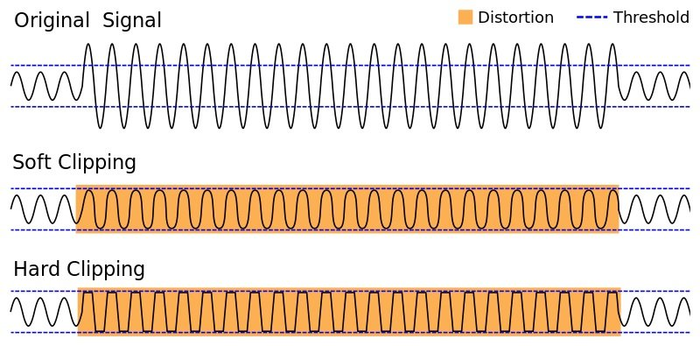

Figure 4: Distortion Varieties [24]

As can be seen in Figure 4, distortion is most simply based around ‘clipping’ – that is, an original signal gets compressed in some way to a certain threshold. The middle waveform, ‘Soft Clipping’, was traditionally first created using tube amplifiers, which contain vacuum tubes (Figure 5). These tubes control the current flow going through it and, when reaching maximum capacity, releases a compressed version of what came in. Even today, despite the inventions of cheaper transistors, many players swear by vacuum tube amps because this variety of distortion creates pleasant-sounding rounded waves and crests.

The downside for this, however, is that it creates complexities when being transferring into the digital domain, as it requires preserving the original signal and applying a distortion algorithm – in Figure 6, an *arctan(x)* function is applied to produce a rounded waveform of the upper threshold that characterises this kind of distortion [25].

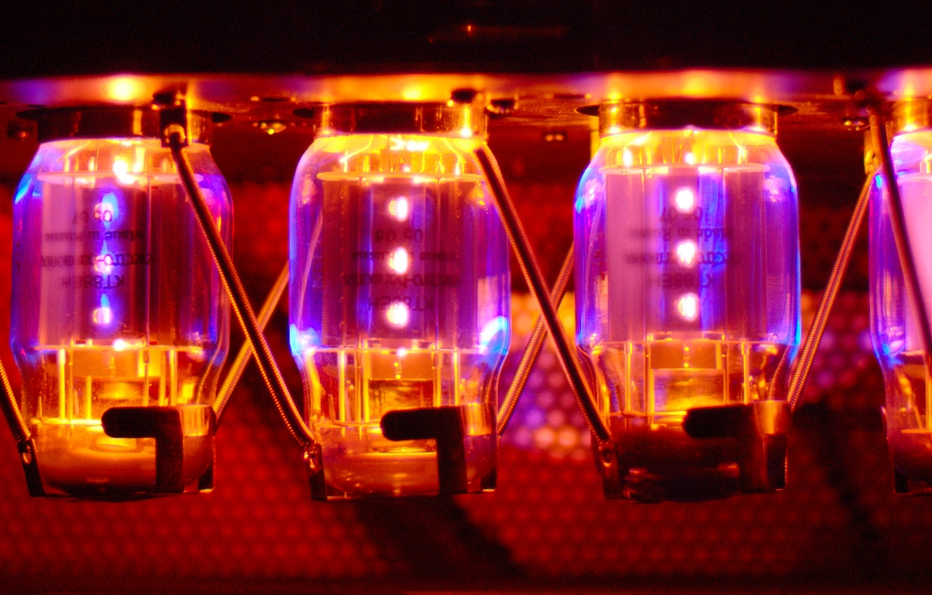

Figure 5: Vacuum Tubes [23]

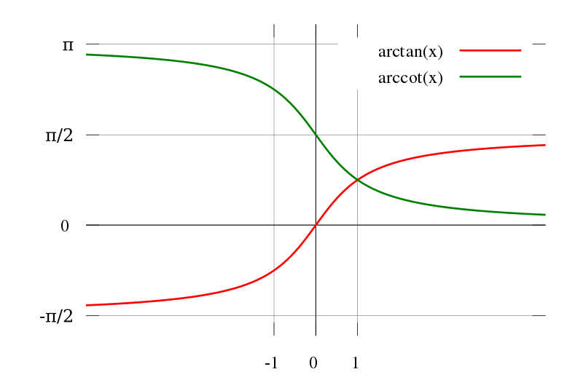

Figure 6: ‘Soft-Clipping’ algorithm graph [25]

On the other hand, ‘Hard Clipping’ (bottom waveform of Figure 4) is generally much more straightforward to produce digitally. Traditionally, this type of clipping was also generated by turning an amplifier up to the highest volumes it is capable of (hence the term ‘overdrive’) and thus creating a near-square waveform, however, the difference this time is that the amplifiers used for this type of distortion were termed *solid-state*, and generally associated with a much rougher sound than the ‘Soft Clipping’ *tube* amplifiers seen previously. Given that there is no need to preserve the original waveform with this type of distortion, it can be implemented in the digital domain with a simple threshold equation (1):

$f(x)\left\{\begin{aligned}axt_{p}, x>t_{p} \\ axt_{n}, x<t_{n} \\ ax, otherwise\end{aligned}\right.$ (1)

Where *f(x)* is the output signal, *x* is the input signal, *tp* and *tn* are positive and negative thresholds respectively, and *a* is a gain factor to compensate for the loss in overall volume.

As one can see, this algorithm of ‘Hard-Clipping’ is very simple to implement and will therefore be the starting point during digital algorithmic development before moving on the more complex effects of echo, reverb and delay. This is to not only manage the timeframe of this project, but also since there is a potential risk with using algorithms that demand more processing power (smaller chips are the priority given our investigations with Aim 2) with, for example, the *arctan(x)* function seen in the ‘Soft-Clip’ version previously.

### Gain/Boost/Fuzz

Previously, it was mentioned that during development of suitable digital signal processing code it is important to prioritise effects that have a similar nature to one another for this multi-effects system. Gain, boost or fuzz are therefore significant, as they are very closely linked with distortion – in fact, the term ‘fuzz’ itself can be used fairly interchangeably with this effect as it too creates a square-like waveform (i.e., ‘Hard Clipping’), but also with added harmonic overtones, making it what is termed in DSP as ‘non-linear’ [27]. In addition, gain and boost are also two words which mean the exact same thing, and are actually even easier to implement than the threshold algorithm seen before:

$f\left(x\right)=bx$ (2)

Where *b* is a constant gain factor.

This is very straightforward, demands no feedback filtering/processing, and would ideally include the ability for *b* to be adjusted as per the Objective laid out in Aim 3. This will be implemented alongside distortion given that the two are very closely related, and it is clear from both Target Market Research and the interview with *Jonathan* that gain (or boost) is something that live performers would be willing to make use of.

### Echo

The echo effect is very interesting in that, like how gain is to distortion, echo forms the basis for many other more complex effects such as reverb and delay. As *Jonathan* correctly pointed out, the echo effect was used significantly by the both National Inventors and Rock and Roll Hall of Fame inductee (the only person to date who has the privilege of being in both) *Les Paul*. His work in what he termed ‘sound-on-sound’ recording along with the invention of the ‘flange’ effect would ultimately lead to the legendary *Gibson* solid-body guitar to be named directly after him [26].

As for the echo effect, in the digital domain, it is our aim to attempt to replicate its physical manifestation as closely as possible. In Figure 7, it can be seen that after projecting a ripple-like sound wave in a room from P, what will return is a summation of reflected waveforms from this original signal but delayed in time and also reduced in gain due to some of it being absorbed by the surface that reflected it.

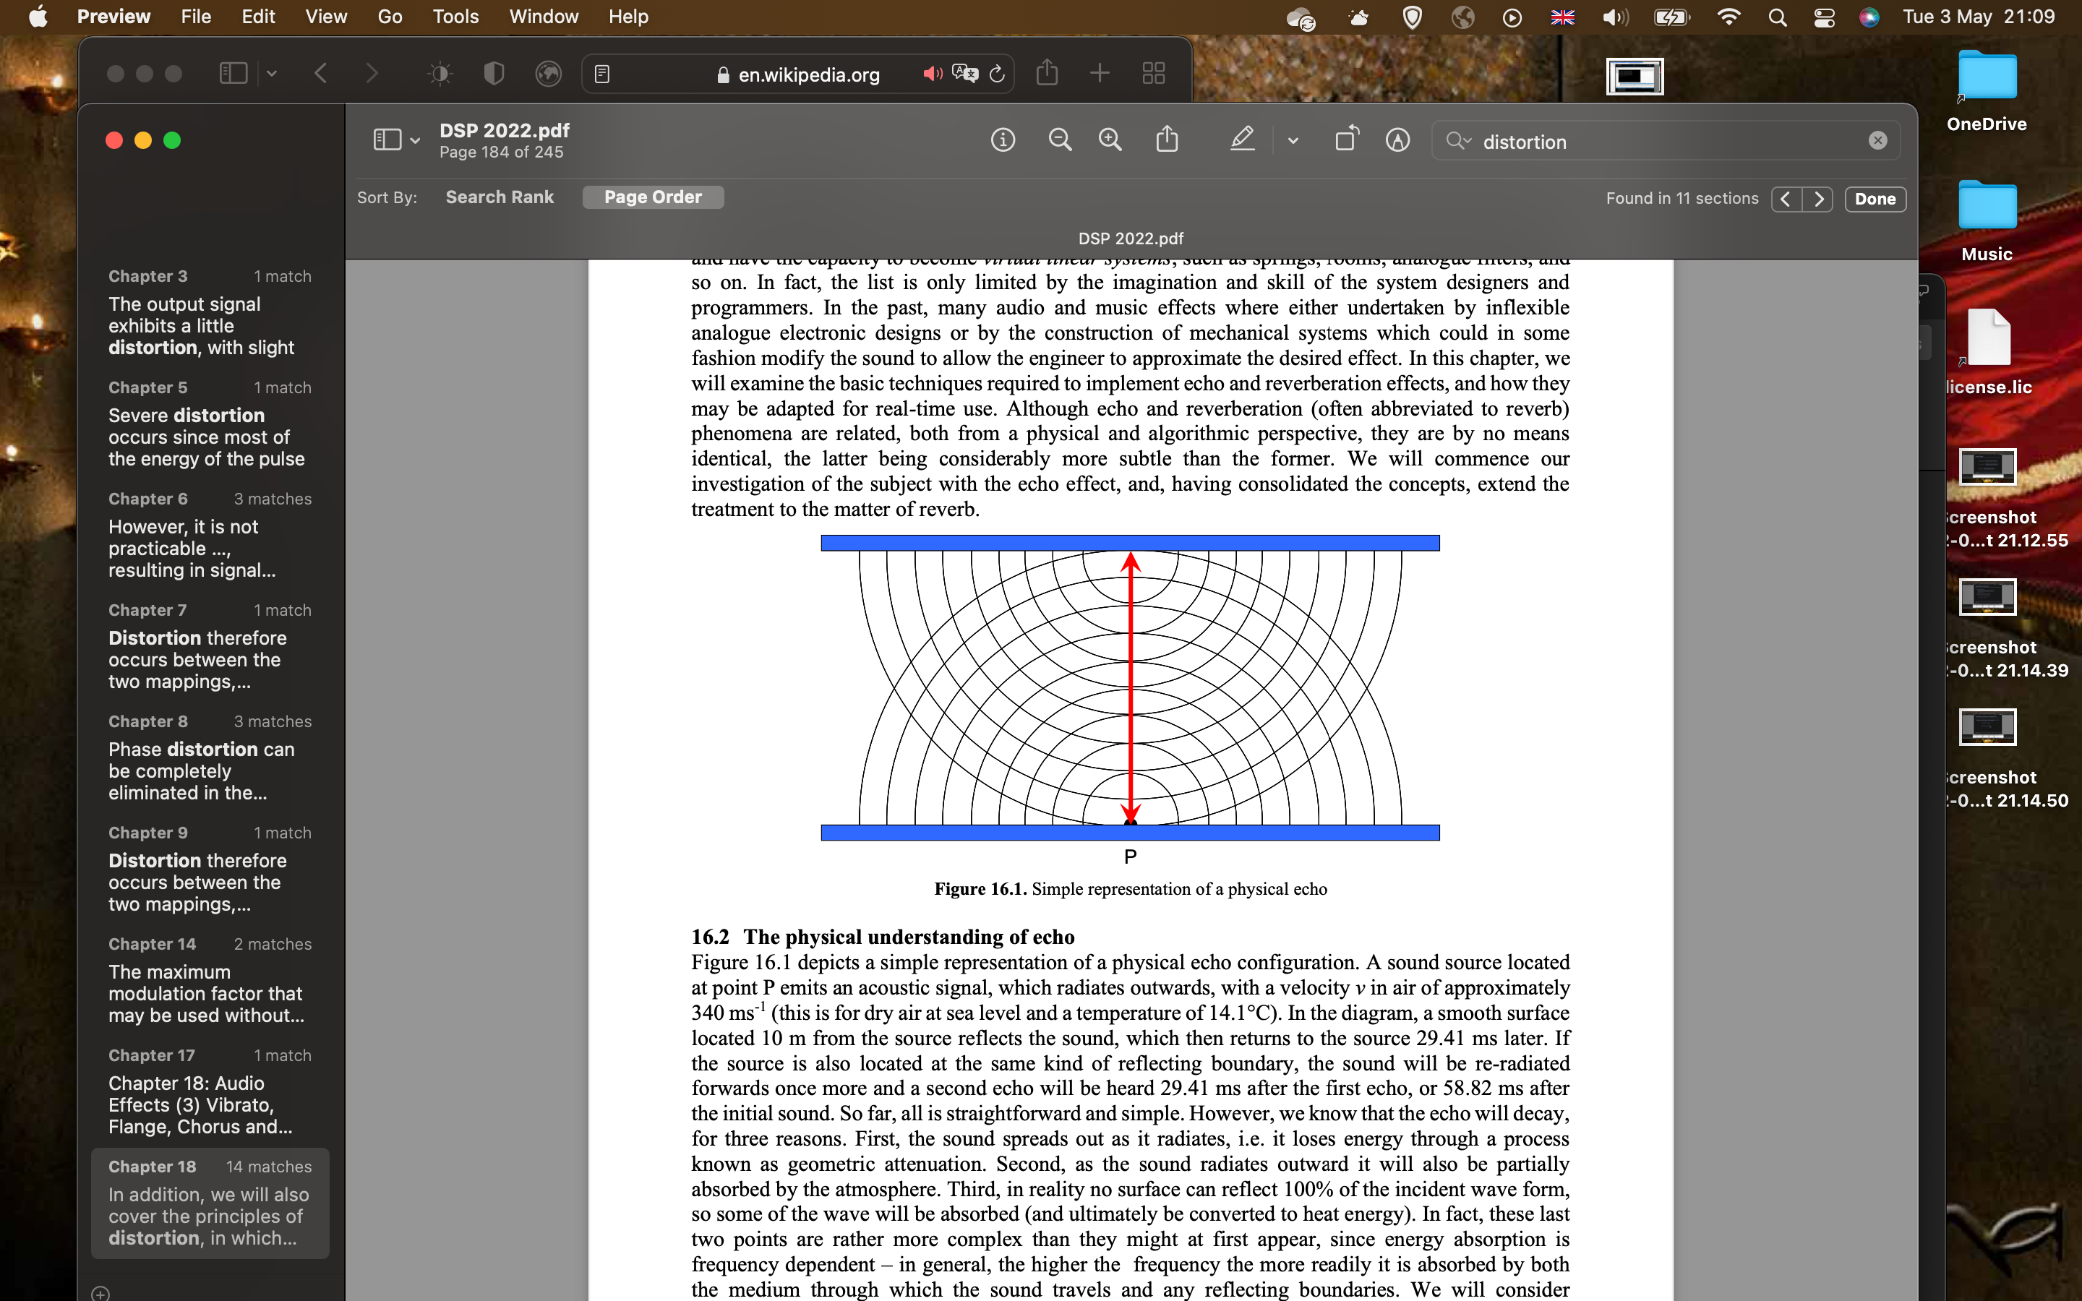

Figure 7: physical manifestation of echo [27]

Diagrammatically, this can be expressed with a summation and a delayed feedback loop. This is displayed in Figure 9, which is what is known as a comb filter.

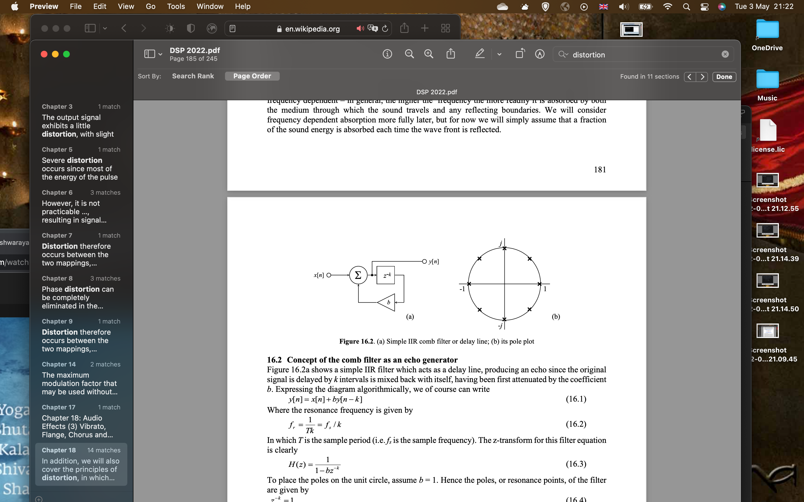

Figure 8: the comb filter [27]

Where *x[n]* is the input signal buffer (*n* being the number of channels), *y[n]* the output buffer, *z^-k* being the delayed response (of *k* intervals), and *b* being the absorption coefficient.

Algorithmically, this can be written as:

$y[n]= x[n]+by[n-k]$ (3)

Equation (3) will thus form the basis of the program once writing the digital effect code begins in Program Design, and, in particular, the distortion algorithms have been completed to a suitably high-quality standard – this shall be confirmed in Peer Review.

### Reverb

The reverb effect started its life electromechanically, in what is turned as a *spring reverberation unit* (Figure 9). This worked by stretching 2 or more springs between an input and an output and, when there was a current produced through the input coil, this provided a twisting force (via magnetism) and a wave is produced and reflected between each end. Transducers at the end of the springs convert the spring motion back into electrical impulses. These make a very pleasant sound, however there is no way to adjust the effect’s features (as demanded by Aim 3) such as the room size or wet/dry signal, so we must turn to a digital alternative to fulfil these requirements.

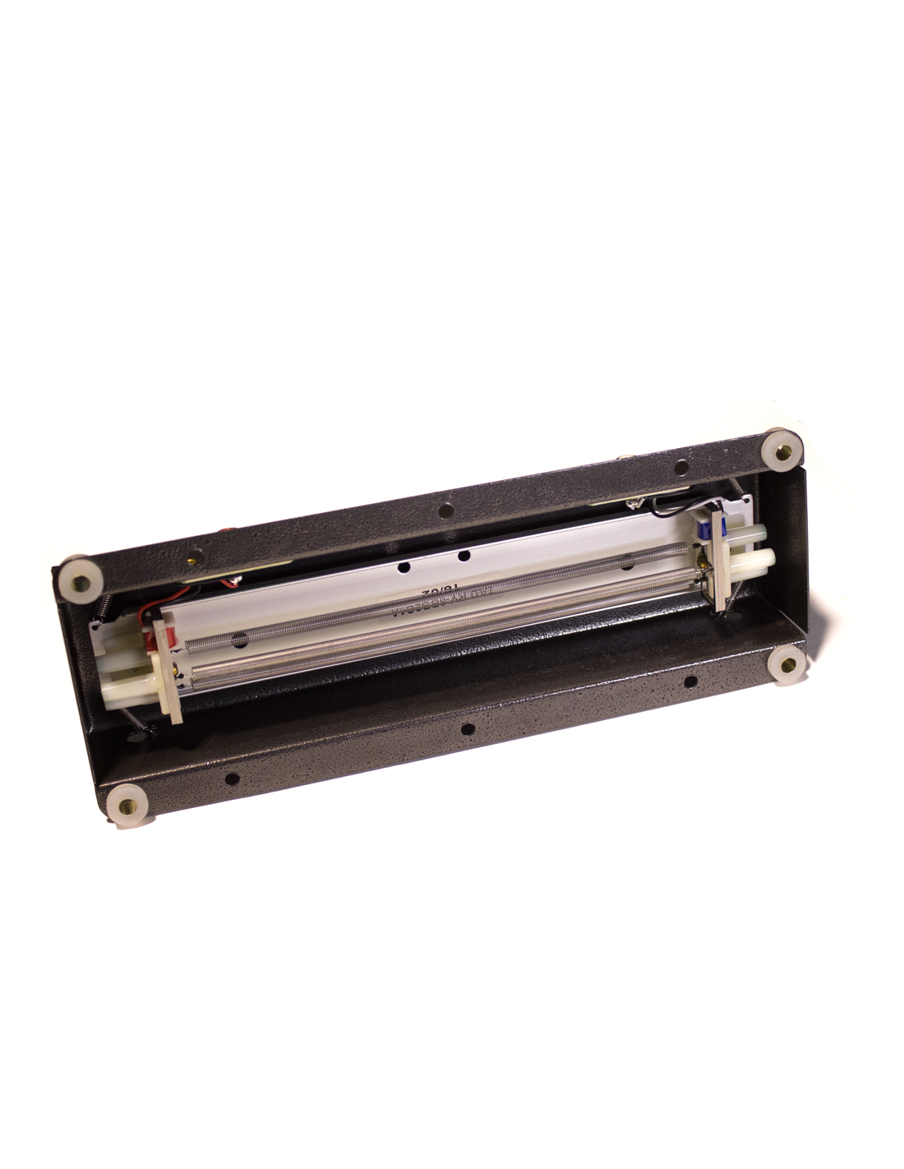

Figure 9: a *spring reverberation unit* [28]

The reason for starting the theory (and thus also the order with which these effects will be programmed) with echo is that it is remarkably closely related to reverb, in fact, so much so that reverb is essentially a *bank* of comb filters, which was seen previously in Figure 8.

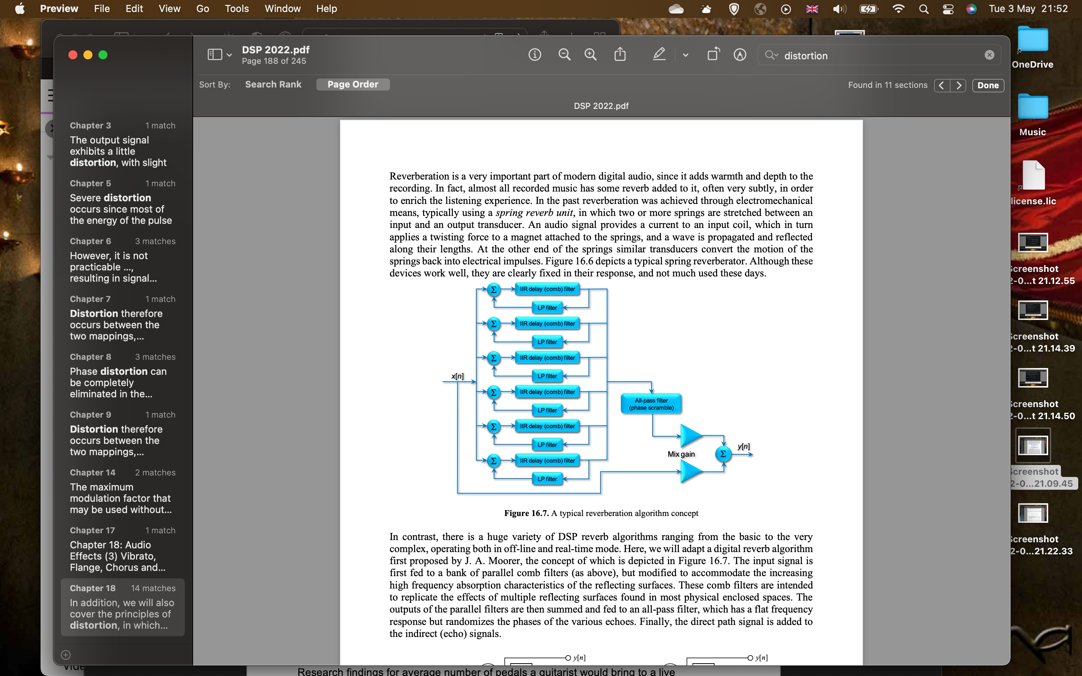

Figure 10: diagram of reverb implementation [27]

Figure 10 displays how one can multiply and extend the echo algorithmic equation (3) as seen before, as a summation of 6 these comb filters can be used to create a warm, room-like effect digitally. If there is sufficient time within the scope of this project, the LP and all-pass filters will be added, however, this is not essential for the operation of the reverb effect (they simply add a more coloured, warmer feel to the sound, as they represent the altered absorption characteristics of the virtual room surfaces and the randomness of the arrival of the incoming reflected waves respectively) and will not be added initially.

It is now possible to fully complete Aim 1, with a full list in chronological (programming) order as to the top 5 most important effects within this project:

1. Gain
2. Distortion (Overdrive – ‘Hard Clipping’)
3. Echo
4. Reverb
5. Delay

Having implemented the echo algorithm, this will lead smoothly into the reverb effect for the reasons given about how one is essentially a building block of another. As a result of this, although it has shown to be a popular effect alongside reverb, the history and theory of delay will not be covered within this section, and it will only be added if there is a sufficient timeframe within this project (hence why it is at number 5 spot above). This is due to the fact that echo is essentially a < 1 second form of delay already (and could be reconstructed to act as a delay with some minimal modifications post-production), and also that it is important that additional processing tasks are kept at a minimal, which leads into the next section [29].

### Performance Test

Previously, during Existing Solutions, the *Raspberry Pi Zero* boasted good levels of effect processing power, but, very importantly, being small enough to be easily mountable inside or outside the guitar as per Aim 2. It even gave the added bonus of Bluetooth connectivity, which could help significantly in achieving Aim 3. However, the *Raspberry Pi* series are composed of more standardised *ARM* cortexes – so how do they compare in DSP?

The *Pi Zero*, before it can successfully be used as an audio unit, will need to have a soundcard attached to it. The reason for this is that it does not come with a built-in audio codec, which is necessary to transfer in/out audio data from the chips peripherals to memory. This is where issues start to arise, as what was a seemingly small, cheap and compact system will now need additional PCBs in order to create a commercially viable product. One of very few soundcards available online for the *Pi Zero* specifically is the *Audio Injector Ultra 2*, contains a *Cirrus Logic* 24 bit codec that runs at 192kHz [30]. Unfortunately, the cost and also size (Figure 12) of this soundcard suddenly makes the *Raspberry Pi Zero* quite undesirable – not only is it far wider than the original dimensions of the *Pi*, but it also brings a lumbering height into the mix that could easy smack against the guitar players elbow, which was something Jonathan was very much against previously. Just how poorly this compares with our next choice of chip will become apparent in the metrics test in Table 2 to follow shortly.

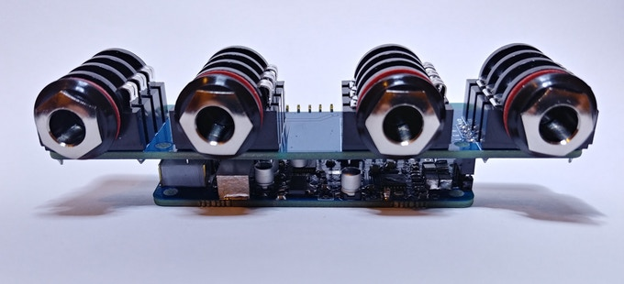

Figure 11: *Audio Injector Ultra 2* Soundcard [1]

Interestingly, the highest sound quality result that was found in the Existing Solutions section was solution 4 – a specialised DSP *SHARC* chip produced by *Analog Devices.* Although it produced a fantastic sound quality, it too was also too large to satisfactorily complete Aim 2 in solving the size issue of mounting the board on the guitar.

Within the laboratories of the 3rd year DSP module at the University, there is another specialised DSP architecture board produced by *Blackfin* (another brand owned by *Analog Devices*)that is used for all of the programming tasks, namely the *BF706* in Figure 12.

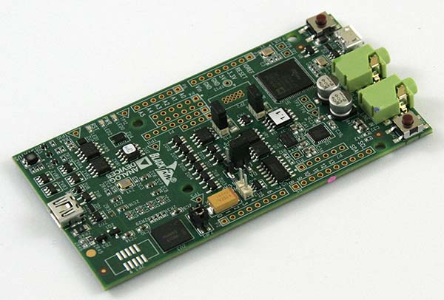

Figure 12: Blackfin EVAL-BF706M-EZLITE [31]

This board was not chosen to be the focus of the entire Digital Signal Processing University module by accident – it is small, powerful, lightweight and also operates at a very low power. Not only this, but it contains its own codec built-in, meaning there is no need to place an unnecessarily bulky soundcard shield on top, which will also reflect in a more reasonable overall cost. Naturally, this leads us into a performance comparison with the *Raspberry Pi Zero*, which can be seen below in Table 2.

|  |  |  |
| --- | --- | --- |
|  | *Raspberry Pi Zero W* | *Blackfin BF706 EZLITE* |
| Clock Rate | 1GHz | 400 MHz |
| RAM Availability | 512MB SDRAM | 1160kB SRAM |
| Power Consumption @ peak performance | <100mA | ~270mA |
| Codec included? | No | Yes – *ADAU1781 SigmaDSP* |
| Programming Software | *Raspbian* | *CrossCore Embedded Studio* |
| Total Size | 65mm x 30mm (+ 152mm x 79mm for soundcard) | 100mm x 50mm |
| Wireless capability? | Yes – Bluetooth 4.2 + LAN | No |
| Overall Cost (for full working system) | £9.30 + £ 73.34 (soundcard) | £59.50 |

Table 2: Performance Metric Comparison

The data from Table 2 was found at [32], [33], [7] for the *Pi* (including [34] for the soundcard), and [35], [36] for the *Blackfin*.

What is interesting about this metric test is that even though the *Pi* has a much higher clock rate than the *Blackfin*, this does not necessarily equate to better performance – as was mentioned earlier, low-end *ARM* cores are not necessarily designed for DSP applications. The significance of the DSP architecture is reflected in the next comparison, the RAM Availability; although, once again, the *Pi* has a high (512MB) amount of RAM available in its SDRAM, the *Blackfin* actually tops this category as it has good SRAM. This is very important, as SRAM (or ‘Static’ RAM) does not demand constant updating (unlike SDRAM, or ‘Synchronised Dynamic’ RAM) and thus has a significantly higher access speed – *very* important for real-time DSP applications [37]. In addition, the *Blackfin* has a lower power consumption, built-in codec support, smaller overall size and is far cheaper when compared with the total cost of the *Pi* + its required soundcard.

The metric test in Table 2 has clearly displayed that it would be far important to use a more powerful, dedicated DSP chip instead for the huge benefits in every category listed, as processing power is always limited in multi-effects pedals. Aim 3 will thus be put aside for now, as the *Blackfin* does not have Bluetooth built-in. This concludes Aim 4 completely (a suitable DSP system has been chosen), and the Design stage shall now commence.

## Program, Circuit and Housing Design

These next 3 sections will be rather brief, and will just give an overview of the design plan for each area of the project (program, circuit and housing).

On the page following (Figure 13) there is a flowchart for the expected algorithm in this program, this will become very important as a basis during the code development process to ensure it is as smooth as possible. Further information about the programming environment will come in the following section; Project Method.

Start

Audio In?

Audio Input READ

Gain Switch ON?

Gain Effect OFF

Gain Effect ON

Distortion Switch ON?

Distortion Effect ON

Distortion Effect OFF

Echo Switch ON?

Echo Effect ON

Echo Effect OFF

Reverb Effect OFF

Reverb Switch ON?

Reverb Effect ON

Audio Output WRITE

Figure 13: Program Flowchart

The circuit diagram is very simple – GPIO is not the main focus for this project, and thus the only necessity for external peripherals at this stage are for the control switches.

In Aim 5, it was directed that in this project the number of control switches should be identified. Using the data given in the forum post of [20], along with *Jonathan’s* view of quality over quantity, the 6 switch panel from eBay in Figure 14, although long, would be ideal [38]. Given there are 4/5 effects, it would be helpful to have the option of an additional switch to use as, for example, a ‘hall’ reverb effect and a ‘room’ reverb.

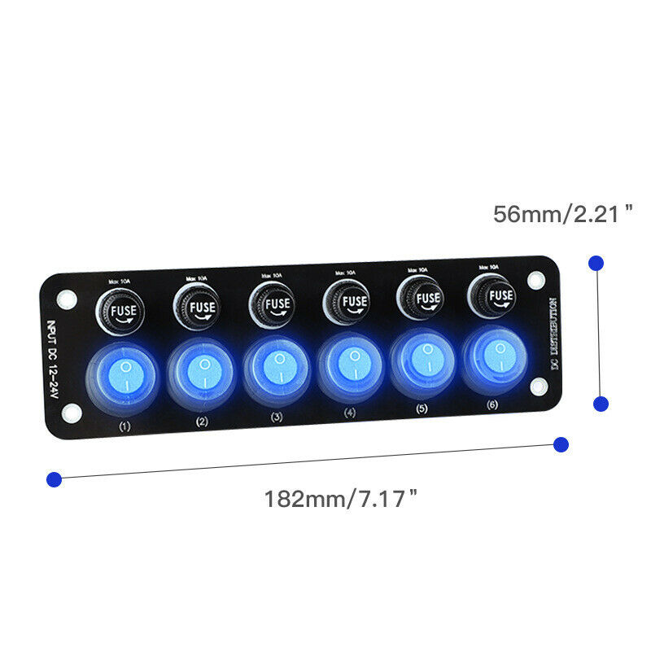

Figure 14: 6 Gang Switch Panel [38]

A schematic diagram is available in **Appendix 2** with the *Blackfin* datasheets to show how this switch panel will be wired up. PORT B was chosen as the port for these 6 rocker switches, as these GPIO pins are connected to the ‘External Connection Points’ [39]. There is one particular wire (PORT B0) which will be set to be constantly high, as this can act as the power for rocker switches (as well as their on-board LEDs).

For the housing, as is seen in the photos in **Appendix 3**, after lifting the scratchpad to reveal the inside of the guitar, there was no room to fit the *Blackfin* without major cutting to the inside of the guitar body. As was pointed out by *Jonathan*, this will not be viable to create a successful commercial product. In order to solve these issues to fulfil Aim 2, there would need to be external mounting. In the last picture of this appendix, a brief plan of how the housing will look is shown (turquoise = *BF706* chip, orange = cables, dark blue = external switch wires, red = mounting), which contains the rocker switch panel seen earlier (not to scale) placed slightly above the strings – this will need to be far enough away from them so as not to disturb the players’ strumming motion. For mounting, a simple solution that requires no cutting would be to use *Velcro* tabs; these are cheap, replaceable, can be easily taken off and will not disturb the structural integrity of the instrument that may turn away owners of more expensive/vintage guitars.

# Project Development

## Project Method

The following is a step-by-step list, including explanations, into the how and why of what methods will be used to create this project.

Software Tools: *CrossCore Embedded Studio*

This IDE is ideal for this project, as it pairs very well with the *Blackfin* series of DSP boards, and offers control not just in C/C++, but also in the *Blackfin* assembly language. This means that hybridised code can be used, which ensures time-critical code is written in assembly (increasing speed and algorithm efficiency) and that slower code can be written in C (condenses code and improves readability). The debugger for this software will also be invoked when errors are encountered, specifically using step-throughs, step-intos and the memory register stack to check the exact values in certain registers to make sure complicated algorithms such as the circular buffers are working as intended.

Hardware Tools: *Blackfin BF706,* Soldering Iron + accessories

The *Blackfin* DSP system is being used given the plethora of performance benefits analysed during the metric test seen previously, along with the fact that it is directly compatible with *CrossCore Embedded Studio*. A soldering iron is important to use for the circuit development, as it ensures a secure, ‘permanent’ join of the electrical components. This will be kept at a minimum; however, it is still important for the SIL header pins on the *Blackfin* and the wire connectors for the external control switches.

Housing Tools: Hot Glue Gun

Although the exact design of the housing casing is yet to be decided, a hot glue will be needed to ensure that the female plugs at the end of wires in the SIL pins do not come loose accidently during minor movements. This could also be used in certain areas of the acrylic case where extra support is needed. Extensive photos will be taken and added to an appropriate appendix within the Housing Development section.

## Program Development

The program can be found in **Appendix 4**. Please note that some comments have extended to the next line so as to keep the margin within 2 cm, sadly this is unavoidable with *Word* formatting. The program shall be broken down and discussed page-by-page.

Page 1

In this page, there are all the relevant #includes, along with various definitions. There is a buffer size of 2, as there are 2 channels: left and right. All the effect coefficients have also been defined, and can be edited later. Since there was not sufficient time in this project to implement a means of editing these parameters off-line (as was the case with Aim 3) via something like Bluetooth, these mostly remain fixed during real-time scenarios.

**Adjustments:** there was a change of variable type from fract32 to long fract across the program – this caused benefits of sound quality when implemented for the ‘XIN’ and ‘YOUT’ buffers, as will be seen in the Peer Review 2 section (coming next).

Page 2

This starts with more definitions, including effect and configuration functions. Next is the start of the flash code (to operate with a portable battery pack), of which, along with the configuration functions, has been imported from 2 separate examples [40][27].

Page 3

Imported flash code functions as above.

Page 4

Imported flash code functions as above.

Page 5

memWrite and memFractWrite (the latter with which was written by the author, the former was not [26]), is used for writing values to memory when any assembly code functions asm{} are used (coming shortly with the echo effect). Next is the start of the effect subroutines, specifically gain and distortion as per the ordering in the program flowchart seen previously. They both pass through the audio input and return an output of some kind of gain (and potentially clipped in the case of the distortion).

Page 6

2 types of distortion have been created – heavy distortion and crunch distortion; the latter has a much higher threshold, and thus a much smaller gain factor than the heavy distortion to compensate for the louder volume (clipping reduces this significantly). The echo effect is also introduced here, and memWrites are invoked since this is the only function where assembly code is used (as opposed to C everywhere else in the program) in order to increase the efficiency and reduce processing power.

**Adjustments:** the line “P0=[0x08010024];I0=P0;” was originally not in the echo algorithm, and as a result meant that it would not process any echoes – it would simply return the input unchanged. What this line does is fetches the saved value in the I0 register between calls, meaning that circular addressing can be used as intended.

Page 7

Remaining echo code is displayed. Reverb code begins. There is a for loop with the variable c, one for each comb filter (6 in this case) as was seen during the development stages. There are 2 forms of reverb used in this program, hall reverb (which has a larger circular buffer length of 25000) and room reverb (which has a length of 25000/2 = 12500, and is seen on the next page). The reverb code is essentially the exact same as the echo code, but written in C as opposed to assembly (this is to avoid the limited number of I registers in assembly code overwriting one another between different comb filters running simultaneously) – the reverb contains a MAC (Multiply-ACcumulate, pivotal for all operations in DSP), but also a special function (decayReverb - 0.063*c) which will ensure that each comb filter denoted by c has a different decay factor. Please see the program comments for further details line-by-line for either echo or reverb.

Page 8

This contains the remaining code for the hall reverb and also the room reverb code. There is a fascinating function that was added here thanks to Peer Review 2 (see Adjustments). The bottom of this page is the start of the initialisation functions, which have been imported from the lecture notes of the University DSP module as before [27].

**Adjustments:** There is a very simple averaging function that was added at the end of each reverb function to help smooth the output (long fract output = (A0 + A1 + A2 + A3) * op;), of which ‘op’ is a fixed value of 0.25 to essentially divide by 4. This is discussed in Peer Review 2.

Page 9

The SPORT interrupt handler was added by request of the project supervisor [27]. Inside, there is a for loop to run through each effect twice: 1 for left channel, 1 for right channel. XIN is passed to the gain function at the beginning and YOUT is taken to be equal to effect4, which is the generated response from the reverb.

Page 10

Here, there is a continuation of the initialisation functions from the bottom of page 8, and are thus imported [27]. This is composed of the SPORT configure, TWI write and codec configure

Page 11

Continuation of codec configure. #pragma is set to highest speed mode, as there are many effects that are demanding processing simultaneously. This is the beginning of the int main, which starts with a segment of imported flash code [40]. Next, the clocks are set to maximum, as if this chip is run outside of the *CrossCore* *IDE,* it is not always guaranteed that the clock will operate at 400 MHz unless specified (the crystal clock is only 25 MHz). Next, there are various start-up configuration functions called (as seen previously), along with the 6 rocker switch GPIO lines set to be inputs.

**Adjustments:** left/right line-in gain was set to 3 dB, and left/right headphone volume was set to 2 dB. This will also be covered in Peer Review 2.

Page 12

At the top of this page is pin 0 of PORT B being set as an output, and being made to run constantly high (as was discussed previously during the design stages) to provide power for the switches. Next is some bitshifting, which is discussed in Adjustments. There is some further assembly code in main – this is purely to initialise and set up the Index, Base and Length registers for the circular buffer used in the echo algorithm. On the while loop (which is always looping if the codec is receiving data), it receives GPIO data and runs them through a bank of if statements, specifically to check which effect the user has activated when clicking one of the switches. All 6 pins have been used for the various effects – the user could potentially switch the order of these if a method of adjustment (i.e., Aim 3 was realised) was given in a later prototype.

**Adjustments:** bitshifting right by 8 is a necessary adjustment for the distortion thresholds, simply due to the fact that the codec is 24 bits, but a long fract is 32 bits. This is also discussed in Peer Review 2.

Page 13

Continuation of the GPIO if statements as above.

### Peer Review 2 – Program

In **Appendix 4** is the finalised code for this project. However, during development, there were a number of features that were added (listed in **Adjustments** as seen previously) for overall quality control. This was helped guided with the help of my colleague *Jonathan*.

|  |  |
| --- | --- |
| Adjustment | Outcome |
| Switch from fract32 to long fract | Improvement in sound quality, especially for distortion. This switch is becoming conventional in DSP circles, given the extremely high precision of the 32 bit long fract (~between -1 to 1). |
| Reverb averaging function | *Jonathan* explained that, to him, the reverb sounded a little too “tinny”. He also said that he could “hear a lot of echoes” when a reverb should sound warmer. This adjustment fulfils this very purpose by smoothing the output signal with previous output values. |
| Increase overall gain to 3 dB and volume to 2 dB | Prevents audio output being drowned out with the intensive multi-processing taking place. It also makes the guitar sound more pronounced with a little more stage presence (an ideal environment for using this pedal). |
| Bitshifting right by 8 | This significantly improved the overall quality of the hard-clipping distortion by removing a lot of the unwanted noise and ‘buzzing’ from the speakers. |

## Circuit Development

The development of the circuit can be seen in **Appendix 5**. Since this was the soldering stage, care was taken to ensure that eye protection was worn, along with being in a well-ventilated area to release harmful fumes and taking care not to touch the hot iron tip (risk of skin burn). Heatshrink tube was used during the soldering of the button panel wires, as this will help with the longevity of the solder joint by protecting it from moisture that could cause rusting and/or breakages. Male SIL header pins were soldered onto the *Blackfin* to allow the female wires to connect with them easily, allowing straightforward testing (the wires could be switched to a different pin if it were discovered that they were in the wrong place) and a firm connection with the chip once the hot glue gun was introduced (coming in the next section).

Initially there was a considerable amount of noise produced in the output when the external control switches were added, likely due to the fact that they were acting as antennas (this is a high-speed digital circuit) that were picking up radiation from other frequencies present in the atmosphere. This was solved by making a faraday cage around the case, along with a ‘poor man’s co-axial cable’, which will again, be covered in the Housing Development section (following next).

## Housing Development

The development of the housing can be viewed in photographic format in **Appendix 6**. A hot glue gun was used for this stage; care was taken to wear gloves (to prevent skin burn) and also wear eye protection to stop loose pieces of hot glue from causing potential blindness. A trip to the hardware store was all that was needed to find the *Velcro* sticky straps, along with some hard plastic brown mounting blocks (as pictured in the appendix) which turned out to be perfect for creating platforms to hot glue directly onto the button bank and also the casing. If this were in an industrial context, nuts and bolts would be used instead with the *Velcro*, as this would give a more professional look than the slightly messier hot glue method (better aesthetics will lead to an increase in sales).

The casing used for the *Blackfin* was a standard pre-lasercut acrylic case used on all the boards in the University labs. The housing is simple to assemble, cheap and sturdy enough to receive sufficient knocks without breaking or cracking. There is also the added bonus that one can look inside and admire the circuitry of the DSP chip. The origins of who designed this case is unknown, so as a result the University DSP module notes shall be referenced for credit of this design [27].

The faraday cage was built around the casing using aluminium foil tape with one of the GPIO pins (see schematic in **Appendix 2**) stuck between this tape and the outside casing, acting as a conductive shield to ground which helps prevent outside interference. The same is true for the long cables running to the external switches – covering these with this tape (whilst ensuring it had a ground connection) was the key to removing this radiative noise problem that the audio output was experiencing. Although perhaps not aesthetically pleasing at this stage, it would be very simple to convert these cables into professional co-axial cables in an industrial context, which would not only save time of production but also give additional protection from the elements (since the outside of these cables are rubber).

# Results

## Overview of Results & Discussion

The finished product photos can be seen in **Appendix 7**. The key features of this product are as follows:

* 4 separate real-time effects, can be invoked simultaneously.
* 6 large blue LED rocker switches.
* 2 optional running modes for both reverb and distortion effects.
* Easy to put on/take off via replaceable *Velcro* tabs.
* No modification to guitar necessary.
* Powered by any portable phone/laptop charger via microUSB.
* Hand operated and 100% portable. No tethering to stationary computer/speaker.
* Low power consumption of <100mW.
* External radiation and noise protection.
* Transparent case, could be made in a variety of different colours.
* Very lightweight, can be carried in a small rucksack.
* Estimated cost <£90 for chip + accessories.

Although there certainly could have been improvements in the workflow, the project timeline was mostly kept on schedule. The deliverables were met in a smooth manner, and there was sufficient time at the end to make adjustments on improving the sound quality of reverb (with the averaging function) and also distortion (changing fract32 variables to long fract).

## Analysis

In this brief analysis, the aims will be run through and whether or not this project met them. Overall this was greatly successful, as 5 out of the 6 aims were completed successfully. The possible improvement highlights will come later during the following sections.

|  |  |
| --- | --- |
| Aim | Met? |
| **Identify any further requirements needed for an electric guitarist/bassist in a live performance setting:** | Yes – it was found that guitarists wanted distortion/reverb/delay effects the most, and not the miscellaneous effects. They also wanted external as opposed to internal pedal mounting. |
| **Identify and solve any problems in fitting the device on the guitar:** | Yes – internal mounting was discounted due to its complications with guitar modification (undesirable commercially) and also issues of noise/feedback. |
| **Derive a working system allowing the user to adjust/reprogram the on-board effects:** | No – this was not possible for this project given that the *Blackfin* does not have built-in Bluetooth control. |
| **4. Identify the most suitable DSP platform for the project:** | Yes – the *Blackfin BF706* was found to be the best system during a metric test with the *Raspberry Pi Zero.* |
| **5. Quantify the number of external control switches needed:** | Yes – target market research along with peer review suggested that between 4-6 switches would be most suitable. 6 were chosen to give different reverb/distortion varieties. |
| **6. Identify the 5 most important musical guitar effects (in order of preference) as a foundation for the project:** | Yes – these are listed in the ‘Reverb’ section of the Program Design stage |

### Peer review 3 – Analysis

In this section, 2 peers – *Jonathan Hadfield* and *Fraser Cowie* – will run through the pros and cons of the pedal in their eyes. These are 2 very different guitar players (*Jonathan* is an electric guitarist, whereas *Fraser* is an electro-acoustic guitarist), which should be a good representation of the 2 ends of the target market that this pedal is aimed at. The photos for these reviews are in **Appendix 9**.

*Jonathan*

|  |  |
| --- | --- |
| Pros | Cons |
| *“Sound quality is nice, distortion and reverb sound much better”* | *“I think all the foil wrap looks a bit messy”* |
| *“I like the look of the blue lights on the switches, they make me stand out”* | *“When I play, I tend to be strumming quite hard – the switches get in the way a little bit”* |
| *“Seeing the circuitry inside is very cool!”* |  |

Since *Jonathan* is an electric player, it is understandable why the housing positioning may be a problem for him, as electric guitars have smaller bodies than acoustic guitars – this could be mitigated by using a smaller button panel in the future. The messy foil was also discussed previously; in a commercial setting, a professional coaxial cable would be used instead.

*Fraser*

|  |  |
| --- | --- |
| Pros | Cons |
| *“The clean effects sound nice overall”* | *“The echo and reverb sometimes sound a bit intense on my guitar”* |
| *“I like that there are many options to choose from”* | *“I would have liked the option maybe of adjusting the reverb room size manually instead of it being pre-set for me”* |
| *“For my playing style, I think the positioning of the pedal on my acoustic is perfect”* | *“the cases and wiring looks a little tacky for me”* |

As mentioned before, acoustics are larger than electrics, which makes sense why *Fraser* had no problem with the size of the chip + accessories. However, the large body would add in additional reverberations on top of the effect, which is likely why he mentioned they sometimes sound a bit intense. This problem could be mitigated (along with *Fraser’s* point on having an adjustment feature) with having a digital rotary switch to control the ‘room size’ of the reverb, which would output a hex value that the digital *Blackfin* could easily read with several GPIO pins. A future prototype could implement this at a minimal cost, with effectively 0 modification to the housing.

# Conclusion

Overall, this was a successful project. The requirements for a stage-ready multi-effects pedal were almost entirely met in the Analysis section above, and there were clear improvements that could be made very simply if future prototypes were built. Since the focus of this product was to build something commercially viable, it appears that with the minor switches to more professional accessories (co-axial cable, digital rotary switches), this would not only be inexpensive to manufacture but also successful in the market – the final Peer Review seen previously indicated that in terms of sound *quality*, with which this report is focused on, there were little to no improvements needed within the algorithm on producing pleasant-sounding musical effects. Very easily, with a more powerful DSP chip and a greater timeframe, this project could be used as a template for programming more effects to be used real-time. There are clearly still many possibilities with this real-time system, and it would be wrong to not leave without the remark about how much freedom the digital domain offers when compared to its fixed analogue counterparts.

# References

1. Roland Corporation & Boss, “RC-505 Loop Station”, (2022), [Online] Available: <https://www.boss.info/uk/products/rc-505/> [accessed 6th May 2022]
2. Tarskitheme.com, ’Firehawk Remote for PC’, 2021, [Online] Available: <https://tarskitheme.com/apps/com.line6.firehawk/> [accessed 6th May 2022]
3. audiofanzine, “Line 6 Firehawk FX”, (2022), [Online], Unpublished, Available: <http://fr.audiofanzine.com/multieffet-guitare-electrique/line-6/firehawk-fx/> [accessed 6th May 2022]
4. Curwen, T, “Line 6 Firehawk FX review”, musicradar., (2015), [Online] Available: <https://www.musicradar.com/reviews/guitars/line-6-firehawk-fx-626489>
5. Eusebio, Y, “Person Using Black Fender Stratocaster”, Pexels, (2018), [Online], Unpublished, Available: <https://www.pexels.com/photo/person-using-black-fender-stratocaster-1656066/> [accessed 6th May 2022]
6. Electrosmash, “Pedal PI - Raspberry Pi ZERO Guitar Pedal.”, (2022), [Online], Unpublished, Available: <https://www.electrosmash.com/pedal-pi> [accessed 6th May 2022]
7. Raspberry Pi, “Raspberry Pi Zero 2 W”, (2022), [Online], Unpublished, Available: <https://www.raspberrypi.com/products/raspberry-pi-zero-2-w/> [accessed 6th May 2022]
8. Blitz City DIY, “Pedal Pi Kit Review - A Raspberry Pi Zero Guitar Pedal”, Youtube, (2017), [Online], Unpublished, Available: <https://www.youtube.com/watch?v=3-Kah1JnDEE&t=1s> [accessed 6th May 2022]
9. Blitz City DIY, “pedalShield Uno: An Arduino Guitar Pedal”, Youtube, (2017), [Online], Unpublished, Available: <https://www.youtube.com/watch?v=FkaQD5KyJzw&t=349s> [accessed 6th May 2022]
10. Electrosmash Shop, “Pedal Pi – Guitar Pedal KIT”, Electrosmash, (2022), [Online], Unpublished, Available: <https://shop.electrosmash.com/product/pedal-pi-kit/> [accessed 6th May 2022]
11. GuitarML, “NeuralPi : RaspberryPi Guitar Pedal using Neural Networks”, Youtube, (2021), [Online], Unpublished, Available: <https://www.youtube.com/watch?v=_3zFD6h6Wrc> [accessed 6th May 2022]
12. Borgerink, K, “DATASHEET DAC+ ADC”, HifiBerry, (2020), [Online], Unpublished, Available: <https://www.hifiberry.com/docs/data-sheets/datasheet-dac-adc/> [accessed 6th May 2022]
13. Gudino, M, “Raspberry Pi 3 vs. Raspberry Pi Zero W”, Arrow, (2018), [Online], Unpublished, Available: <https://www.arrow.com/en/research-and-events/articles/raspberry-pi-3-vs-raspberry-pi-zero-w> [accessed 6th May 2022]
14. Matt, “Raspberry Pi Mechanical Drawings & Dimensions”, raspberrypi-spy.co.uk, (2012), [Online], Unpublished, Available: <https://www.raspberrypi-spy.co.uk/2012/03/mechanical-data-dimensions> [accessed 6th May 2022]
15. Sink, A, “Putting a Ring Modulator Guitar Pedal Inside a Guitar”, sinkhacks.com, (2015), [Online], Unpublished, Available: <http://sinkhacks.com/circuit-bent-ring-modulator-built-in-pedal-guitar/> [accessed 6th May 2022]
16. BBC Research & Development, Internet Research & Future Services (IRFS), “Ring Modulator \ info demo code”, BBC, (N/A), [Online], Unpublished, Available: <https://webaudio.prototyping.bbc.co.uk/ring-modulator/> [accessed 6th May 2022]
17. Analog Devices, “SHARC Processor Architectural Overview”, (2022), [Online], Unpublished, Available: <https://www.analog.com/en/products/landing-pages/001/sharc-processor-architectural-overview.html> [accessed 6th May 2022]
18. Messina, A, “3 Real-Time Audio DSP Effects [Project Demo]”, Youtube, (2021), [Online], Unpublished, Available: <https://www.youtube.com/watch?v=fMQC7dKWhlk> [accessed 6th May 2022]
19. National Guitar Academy, “Guitar Effects: The Ultimate Guide”, (N/A), [Online], Unpublished, Available: <https://nationalguitaracademy.com/guitar-effects/> [accessed 6th May 2022]
20. hdoran, maggior, “Best multi effects pedal for stage”, Guitartricks.com, (2017), [Online], Unpublished, Available: <https://www.guitartricks.com/forum/thread.php?t=46872> [accessed 6th May 2022]
21. Sharma, A, “Best guitar effects pedals 2022: our pick of effects in every pedal category”, musicradar., (2022), [Online], Unpublished, Available: <https://www.musicradar.com/news/the-best-guitar-effects-you-can-buy-right-now> [accessed 6th May 2022]
22. Hayes, M, “The Most Popular Sound Effects For Guitars”, guitarcoaching.com, (N/A), [Online], Unpublished, Available: <https://www.guitarcoaching.com/guitarlessonsblog/guitar-tips/802/the-most-popular-sound-effects-for-guitars/> [accessed 6th May 2022]
23. Bouchard, G, “A brief history of guitar distortion”, ontheaside.com, (2014), [Online], Unpublished, Available: <https://ontheaside.com/uncategorized/a-brief-history-of-guitar-distortion/> [accessed 6th May 2022]
24. Ryazanov, M, “Clipping compared to limiting.svg”, [CC BY-SA 3.0], Wikimedia, (2012), [Online], Unpublished, Available: <https://commons.wikimedia.org/wiki/File:Clipping_waveform.svg> [accessed 6th May 2022]
25. Heeb, “Soft Clipping Algorithm”, kvraudio.com, (2007), [Online], Unpublished, Available: <https://www.kvraudio.com/forum/viewtopic.php?t=195315> [accessed 6th May 2022]
26. Paul, L, “MULTI-TRACK RECORDING”, Les Paul Foundation, (2021), [Online], Unpublished, Available: <https://www.les-paul.com/multi-track-recording/> [accessed 6th May 2022]
27. Gaydecki, P, “Digital Signal Processing”, School of Electrical and Electronic Engineering, The University of Manchester, (2022), [Online], Available: <https://online.manchester.ac.uk/bbcswebdav/pid-12959843-dt-content-rid-129332464_1/xid-129332464_1> [accessed 6th May 2022]
28. Befaco, “Spring Reverb Assembled Module”, (2021), [Online], Unpublished, Available: <http://shop.befaco.org/assembled/14-spring-reverb.html> [accessed 6th May 2022]
29. Samplecraze, “Delay Effect - what is it and how does it work”, (N/A), [Online], Unpublished, Available: <https://samplecraze.com/tutorials/delay-effect-what-is-it-and-how-does-it-work/> [accessed 6th May 2022]
30. Ruggeri, L, “Audio Injector Ultra Sound Card for Your Pi Now on Kickstarter”, openelectronics, (2018), [Online], Unpublished, Available: <https://www.open-electronics.org/audio-injector-ultra-sound-card-for-your-pi-now-on-kickstarter/> [accessed 6th May 2022]
31. Gawryluk, A, “ADSP-BF706 EZ-KIT Mini czyli DSP w świecie Arduino”, Mikro Kontroler, (2015), [Online], Unpublished, Available: <https://mikrokontroler.pl/2015/06/18/adsp-bf706-ez-kit-mini-czyli-dsp-w-swiecie-arduino/> [accessed 6th May 2022]
32. Matt, “Raspberry Pi Power Consumption Data”, raspberrypi-spy.co.uk, (2018), [Online], Unpublished, Available: <https://www.raspberrypi-spy.co.uk/2018/11/raspberry-pi-power-consumption-data/> [accessed 6th May 2022]
33. Pimoroni, “Raspberry Pi Zero W”, Raspberry Pi, (N/A), [Online], Unpublished, Available: <https://shop.pimoroni.com/products/raspberry-pi-zero-w?variant=39458414264403> [accessed 6th May 2022]
34. Audio Injector, “Audio Injector Ultra 2 Sound Card for The Raspberry Pi”, Amazon, (2018), [Online], Unpublished, Available: <https://www.amazon.com/Audio-Injector-Ultra-Sound-Raspberry/dp/B07HQ8FFPJ#customerReviews> [accessed 6th May 2022]
35. Blackfin, “EVAL-BF706M-EZLITE”, Analog Devices, (2022), [Online], Available: <https://www.analog.com/en/design-center/evaluation-hardware-and-software/evaluation-boards-kits/eval-bf706-mini.html#eb-overview> [accessed 6th May 2022]
36. Mouser “ADSP-BF706”, (2022), [Online], Unpublished, Available: <https://www.mouser.co.uk/ProductDetail/Analog-Devices/ADSP-BF706?qs=%252BEew9%252B0nqrCj3BspFN9y0g%3D%3D> [accessed 6th May 2022]
37. betweendifference, “Difference Between SRAM and SDRAM”, differencenetweenz.com, (2017), [Online], Unpublished, Available: <https://differencebetweenz.com/difference-sram-sdram-sram-vs-sdram/> [accessed 6th May 2022]
38. autoparts-accessories, “6 Gang 12V/24V Dual USB LED Rocker Switch Panel Decal For Car Truck Boat Marine”, eBay, (2022), [Online], Unpublished, Available: <https://www.ebay.co.uk/itm/313724696418?_trkparms=ispr%3D1&hash=item490b72f762:g:pIAAAOSwHK9hdlH3&amdata=enc%3AAQAGAAAA8M0CLSj%2FxY7mhJaGaPP0uIjqtth4OSD4hLBnEc1is4GLF30GTR%2BLrORFKZ%2Bp6wl4tQf%2BdfcPbHGE1WUwy%2FUkC%2B5pDSuFmBgbCVlzDXsvo3ydQ%2FTj7107LuSdQrlLYoM0CGzlxlqYejM2UGMkI5o7gekAqJ1cjnZdpMcw5isebbI3JGvTtqmHIdON0pEwY99EASDjBbrmWRoGDeOTD%2FK%2BHqFiUb7SXlMxUCL78o8WbycE%2Fsf5hOAwROLd%2FclukjHT%2Bru1asqpuDwGFXafoF7TSP4zXLSEdQ8e2ZzU507PXNURbDNHLuFH3f%2FSQeLutcR9Ng%3D%3D%7Ctkp%3ABFBMqqm545Jg> [accessed 6th May 2022]
39. Blackfin, “ADSP-BF706”, Analog Devices, (2019), [Online], Available: <https://www.analog.com/en/products/adsp-bf706.html#product-overview> [accessed 6th May 2022]
40. Gaydecki, P, “Two really simple, stand-alone programs for flash read/write on EZ-kit mini. One in assembly and one in C.”, ADI EngineerZone, Analog Devices, (2021), [Online], Unpublished, Available: <https://ez.analog.com/dsp/blackfin-processors/bf70x/f/q-a/547967/two-really-simple-stand-alone-programs-for-flash-read-write-on-ez-kit-mini-one-in-assembly-and-one-in-c> [accessed 6th May 2022]

# Appendices

## Appendix 1 – Project Timeline

This timeline is a bullet-point list of the methodologies which aim to have been completed when their specific month **ends**. There are risks considered in each and some possible ways of overcoming them.

**October 2021**

* Necessary parts have been ordered and delivered, waiting to begin testing.
* Relevant software/further resources have been acquired and downloaded, ready to be used.
* Relevant technical knowledge for basic DSP assembly code and C/C++ has been gathered and understood. These will be necessary to refer to later when testing/programming begins.

**RISKS:** Some parts may take weeks to deliver due to overseas postage/global semiconductor shortage – order parts as quickly as possible to mitigate them not being available in time for testing.

**November 2021**

* Data about the requirements for the project (project aims 1, 2, 5 and 6) has been gathered from relevant sources e.g. online research and peer questionnaires. Conclusions will be made about each aim in order to have a bedrock view on what the target market demands.
* Testing as to the best DSP platform (aim 1) has been completed thoroughly, with a platform chosen to move forward with.
* Programming of the first (and most important from the research data) effect has begun.

**RISKS:** Peer review feedback may not be as representative of the target market due to a smaller sample size – a greater reliance on the online data is necessary. Testing could also overrun longer than needed – this should be kept to the strict requirements laid out in the objectives, with a DSP system chosen as early as possible.

**December 2021**

* A breadboard of the full circuit, including all the control switches, has been completed.
* Programming of the first effect is complete, with thorough testing to ensure seamless operation.
* A basic and rudimentary form of wireless (such as Bluetooth) communication between a smartphone and the DSP chip has been programmed and completed.
* Begin populating Final Report.

**RISKS:** Programming a DSP effect may take longer than anticipated, as I personally have no experience with DSP assembly code – considerations should be made to code the effect offline first (and perhaps using slower code in C/C++ where necessary), and then move into real-time as soon as the offline has been established.

**January 2021**

* If project is on schedule, then completion of 1 additional effect in order to gauge the result of a multi-layered effect system.
* Begin designing PCB and possible housing.

**RISKS:** Possibility of huge increase in complexity having 2 effects working together in tandem on the same signal – if it is taking too much time then begin focus instead on PCB design and housing.

**February 2021**

* PCB and housing designs complete. Begin and complete fabrication of PCB with soldering complete.
* Complete PCB testing after soldering to confirm validity.
* Begin housing fabrication and finish any additional ordering of guitar equipment needed for PCB integration.

**RISKS:** Any further ordering may also demand longer shipping time – establish if anything needs to be ordered well in advance (start of the month) and order as soon as possible.

**March 2021**

* Complete housing fabrication.
* Complete board integration into a guitar, performing all necessary adjustments to the guitar body/scratchpad.
* Final project testing completed in a variety of conditions, ensuring there are no program glitches or outside interference that could adversely affect the internal pedal.
* Complete > 50% of the Final Report.

**RISKS:** Guitar adjustments has the potential to use up a lot of time – perform rigorous measurements of all internal and external dimensions necessary well in advance and only make adjustments where needed. Testing may also not go successfully, meaning delays and backtracking – this is mitigated somewhat by the timeline giving space next month for desirable (not essential) features.

**April 2021**

* If final project testing is complete, then complete programming of remaining 3 guitar effects with testing.
* If remaining effects programming is complete, then complete programming of a more refined, user-friendly app system to communicate with the internal DSP board.
* Complete Final Report.
* Begin preparations for Final Project Presentation.

**RISKS:** Final Report may take longer than planned – look ahead and read what the Final Report demands right from the start of the project and ensure that any important points are added to a skeleton copy from the beginning of this timeline towards the end. This will speed up the report writing tremendously.

**May 2021**

* Complete Final Project Demonstrations.

**RISKS:** Project could show erratic behaviour and work only at certain times as opposed to all the time – ensure that testing is rigorous at every stage of the project, including subjecting the guitar signal to many possible combinations of volume/tone potentiometer readings along the way. Another mitigation is to focus on 100% reliability of a single effect in the guitar pedal, as opposed to a range of effects with a very scattergun approach to how well they perform overall.

## Appendix 2 – Schematic Diagrams

**PWR**

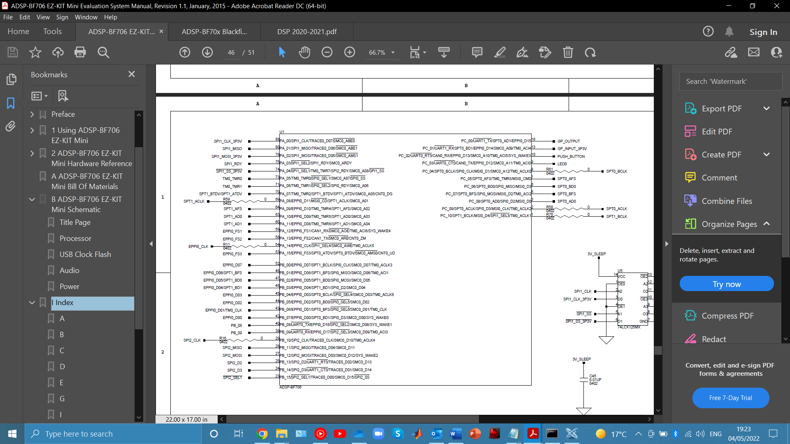

**2**

**6**

**5**

**4**

**3**

**1**

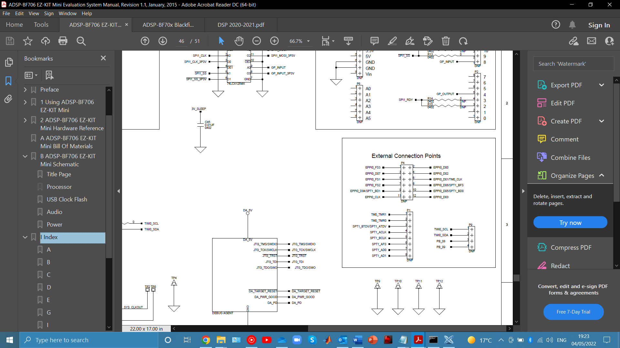

**6**

**3**

**PWR**

**5**

**4**

**2**

**1**



**GND**

**GND (shielding)**

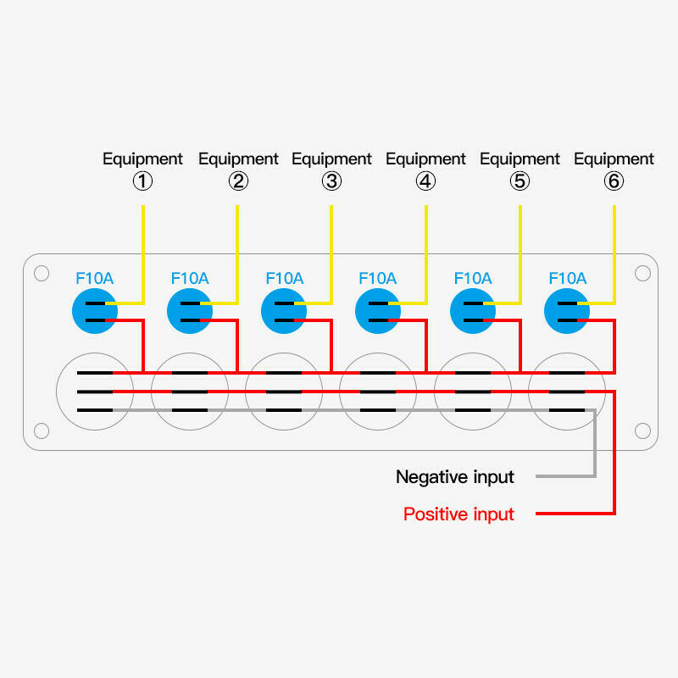

## A picture containing indoor, red Description automatically generatedA picture containing indoor, red, guitar Description automatically generatedA picture containing red Description automatically generatedA picture containing indoor, floor, guitar Description automatically generated

## Appendix 4 – Program Code (Full)

//author: Harry Moss

//date: 05.05.2022

//all relevant includes

#include <stdio.h>

#include <cdefBF706.h>

#include <defBF706.h>

#include <math.h>

#include "stdfix.h"

#include <sys/platform.h>

#include "adi_initialize.h"

#include <services/int/adi_int.h>

#include <stdint.h>

#include <stdbool.h>

#include <services/gpio/adi_gpio.h>

//C definitions

#define codec_in ((volatile long fract *)0x2004D0C4)

#define codec_out ((volatile long fract *)0x2004D040)

#define BUFFER_SIZE 2 //size of buffer to transmit

#define REV_ROOM_SIZE 25000 //reverb room size

long fract XIN[BUFFER_SIZE]; //input buffer

long fract YOUT[BUFFER_SIZE]; //output buffer

//GAIN

unsigned gainCoeff = 3; //gain effect coefficient

char gainPWR = 0; //gain ON/OFF

//DISTORTION

long fract pThres = 0.0007; //distortion upper bound

long fract nThres = -0.0007; //distortion lower bound

char heavyDistPWR = 0; //distortion heavy ON/OFF

char crunchDistPWR = 0; //distortion crunch ON/OFF

//ECHO

unsigned filterLengthEcho = 2000; //echo buffer length

long fract decayEcho = 0.8; //echo decay

char echoPWR = 0;

//REVERB

long fract decayReverb = 0.75; //reverb decay

long fract A0 = 0; //accumulator register

long fract A1 = 0; //delayed feedback averages

long fract A2 = 0; //^^

long fract A3 = 0; //^^

long fract op = 0.25; //operator

long fract i[6][REV_ROOM_SIZE] = {0}; //6 comb filter buffer

unsigned k = 0; //circular buffer position

char reverbHallPWR = 0; //reverb hall ON/OFF

char reverbRoomPWR = 0; //reverb room ON/OFF

uint32_t data; //GPIO receive data

//effect definitions

long fract gain (long fract input);

long fract distortion (long fract input);

long fract echo (long fract input, long fract dec, unsigned length);

long fract reverb (long fract input);

//configuration functions

void TWI_write(uint16_t, uint8_t);

void codec_configure(void);

void sport_configure(void);

void init_SPORT_DMA(void);

void SPORT0_RX_interrupt_handler(uint32_t iid, void *handlerArg);

void memWrite(unsigned, unsigned);

void memFractWrite(unsigned, long fract);

//flash code START

/*

Program FlashMem2 is a simple demonstration program for writing and reading data to/from

the serial flash memory on the ADSP-BF706 EZ-KIT Mini board. It does not require any

external files other than register addresses. It is very basic and contains no error

checking. However, it illustrates how to establish communication and interact with the

W25Q32 chip.

Author: Patrick Gaydecki

Date : 28.07.2021

*/

void flash_delay(void);

void flash_initialize(void);

void flash_write_byte(uint8_t);

void flash_sector_erase(int);

void flash_read_page(int, uint8_t[]);

void flash_write_page(int, uint8_t[]);

uint8_t const write_enable=0x06;

uint8_t const erase=0x20;

uint8_t const unlock=0x98;

uint8_t const write_page=0x2;

uint8_t const write_disable=0x4;

uint8_t const read_page=0x03;

uint8_t lo_addr;

uint8_t mid_addr;

uint8_t hi_addr;

int n;

// Function flash_delay is a crude delay function

void flash_delay()

{

for(n=0;n<6000000;n++){};

}

// Function flash_initialize sets Port B as SPI, enables the flash write, and

// unlocks the global erase feature.

void flash_initialize()

{

*pREG_PORTB_FER = 0x7c00; // Set Port B as SPI

*pREG_PORTB_FER_SET = 0x7c00;

*pREG_PORTB_DIR_SET = 0x8000;

*pREG_SPI2_CLK = 0x1; // Set bit rate rate

*pREG_SPI2_CTL = 0x3; // Enable SPI

*pREG_PORTB_DATA_CLR = 0x8000; // Flash chip enable

flash_write_byte(write_enable); // Write enable the flash

*pREG_PORTB_DATA_SET = 0x8000; // Flash chip disable

*pREG_PORTB_DATA_CLR = 0x8000;

flash_write_byte(unlock); // unlock all sectors

*pREG_PORTB_DATA_SET = 0x8000;

}

// Function flash_write_byte writes a single byte to the flash.

void flash_write_byte(uint8_t command)

{

*pREG_SPI2_TWC = 0x1;

*pREG_SPI2_TFIFO = command;

*pREG_SPI2_TXCTL = 0xD;

while((*pREG_SPI2_STAT & 0x800)==0x0){} // Wait for TX complete

*pREG_SPI2_TXCTL = 0;

}

// Function flash_sector_erase erases an entire sector. Here it is sector 0.

void flash_sector_erase(int sectorw)

{

sectorw*=4096; // Decompose the address

lo_addr=sectorw;

mid_addr=sectorw>>8;

hi_addr=sectorw>>16;

*pREG_PORTB_DATA_CLR = 0x8000;

flash_write_byte(write_enable); // Write enable the flash;

*pREG_PORTB_DATA_SET = 0x8000;

*pREG_PORTB_DATA_CLR = 0x8000;

flash_write_byte(erase); // Erase the sector;

flash_write_byte(hi_addr);

flash_write_byte(mid_addr);

flash_write_byte(lo_addr);

*pREG_PORTB_DATA_SET = 0x8000;

flash_delay(); // Lazy delay. Should check status

}

// Function flash_read_page reads an entire 256-byte page

void flash_read_page(int pager, uint8_t data_rd[])

{

*pREG_PORTB_DATA_CLR = 0x8000;

pager*=256; // Decompose the address

lo_addr=pager;

mid_addr=pager>>8;

hi_addr=pager>>16;

flash_write_byte(read_page); // Read page instruction

flash_write_byte(hi_addr);

flash_write_byte(mid_addr);

flash_write_byte(lo_addr);

*pREG_SPI2_RXCTL=0x5;

for (n=0;n<256;n++)

{

*pREG_SPI2_RWC = 0x1;

while((*pREG_SPI2_STAT & 0x400)==0x0){} // Wait for RX complete

data_rd[n]=*pREG_SPI2_RFIFO;

}

*pREG_SPI2_RXCTL=0;

*pREG_PORTB_DATA_SET = 0x8000;

}

// Function flash_write_page writes an entire 256-byte page

void flash_write_page(int pagew, uint8_t data_wr[])

{

pagew*=256; // Decompose the address

lo_addr=pagew;

mid_addr=pagew>>8;

hi_addr=pagew>>16;

*pREG_PORTB_DATA_CLR = 0x8000;

flash_write_byte(write_enable); // Write enable the flash;

*pREG_PORTB_DATA_SET = 0x8000;

*pREG_PORTB_DATA_CLR = 0x8000;

flash_write_byte(write_page); // Write page instruction;

flash_write_byte(hi_addr);

flash_write_byte(mid_addr);

flash_write_byte(lo_addr);

for (n=0;n<256;n++) {flash_write_byte(data_wr[n]);} // Now write any 256 bytes

*pREG_PORTB_DATA_SET = 0x8000;

flash_delay();

}

//flash code END

// memWrite writes a 32-bit value to a memory location

// memFractWrite does the same but with a long fract

// memFractRead reads a long fract from memory

void memWrite(unsigned address, unsigned memvalue)

{

unsigned *towrite;

towrite = (unsigned*)address;

*towrite=memvalue;

}

void memFractWrite(unsigned address, long fract memvalue)

{

long fract *towrite;

towrite = (long fract*)address;

*towrite=memvalue;

}

long fract memFractRead(uint32_t address)

{

long fract *core_address = (long fract *)address;

return(*core_address);

}

//EFFECT FUNCTIONS

long fract gain (long fract input){

if (gainPWR == 1){ //gain ON/OFF?

return input*gainCoeff;

}

else{

return input;

}

}

long fract distortion (long fract input){

if (heavyDistPWR == 1){ //distortion heavy ON/OFF?

if (input >= pThres){ //if over upper threshold, hard clip

return pThres*11; //gain = 11 for powerful sound

}

if (input <= nThres){

return nThres*11; //if under lower threshold, hard clip

}

else{

return input*11;

}

}

if (crunchDistPWR == 1){ //distortion crunch ON/OFF?

if (input >= pThres*8){ //as before, but with a higher threshold

return (pThres*8)*2; //gain = 2 for crunchier sound

}

if (input <= nThres*8){

return (nThres*8)*2;

}

else{

return input*2;

}

}

else{

return input; //otherwise return input

}

}

long fract echo (long fract input, long fract dec, unsigned length){

if (echoPWR == 1){ //echo ON/OFF?

memFractWrite(0x11906004, input); //write input, decay and length into memory

memFractWrite(0x08010030, dec);

memWrite(0x0801002c, length*4);

asm

(

"P0=[0x08010024];I0=P0;" // Reload I0

"P0=[0x0801002c];L0=P0;" // Load delay into L0

"R1=[0x08010030];" // Decay coefficient

"R0=[0x11906004];" // Get codec value

"A1 = R0;" // Clear A0 and get data/taps

"R0=[I0];" //load into R0 the value at the start of the buffer

"A1:0+= R0 * R1;" // Echo

"R1=A1:0;[0x11906004]=R1;"

"[I0++]=R1;" //put result at the start of the next buffer

"P0=I0;[0x08010024]=P0;" // Load filter length into P0

);

long fract output = memFractRead(0x11906004); //get output

return output;

}

else{

return input; //otherwise, return input

}

}

long fract reverb (long fract input){

if (reverbHallPWR == 1){ //reverb hall ON/OFF?

for (unsigned c = 1; c < 7; c++){ //6 comb filters

if (k >= REV_ROOM_SIZE){ //start overwriting old values when at the end of circular buffer

k = 0;

}

A0 = input;

A0 += (i[c][k] * (decayReverb - 0.063*c)); //MAC with function to give different decay for each filter

i[c][k++] = A0; //place in next address of circular buffer

}

long fract output = (A0 + A1 + A2 + A3) * op; //averaging system to smooth output

A1 = A0;

A2 = A1;

A3 = A2;

return output;

}

else if (reverbRoomPWR == 1){ //as before

for (unsigned c = 1; c < 7; c++){

if (k >= (REV_ROOM_SIZE/2)){ //circular buffer length/2 to give a smaller 'room size'

k = 0;

}

A0 = input;

A0 += (i[c][k] * (decayReverb - 0.05*c));

i[c][k++] = A0;

}

long fract output = (A0 + A1 + A2 + A3) * op;

A1 = A0;

A2 = A1;

A3 = A2;

return output;

}

else{ //otherwise, return input

return input;

}

}

// Subroutine DMA_init initialises the SPORT0 DMA0 and DMA1 in auto-buffer mode, p19–39 and p19–49, BHRM.

void init_SPORT_DMA()

{

*pREG_DMA0_ADDRSTART = YOUT; // points to start of SPORT0_A buffer

*pREG_DMA0_XCNT = BUFFER_SIZE; // no. of words to transmit

*pREG_DMA0_XMOD = 4; // Word length, increment to find next word in the buffer

*pREG_DMA1_ADDRSTART = XIN; // points to start of SPORT0_B buffer

*pREG_DMA1_XCNT = BUFFER_SIZE; // no. of words to receive

*pREG_DMA1_XMOD = 4; // Word length, increment to find the next word in buffer

*pREG_DMA0_CFG = 0x00001221; // SPORT0 TX, FLOW = autobuffer, MSIZE = PSIZE = 4 bytes

*pREG_DMA1_CFG = 0x00101223; // SPORT0 RX, DMA interrupt when x count expires

}

// Function SPORT0_RX_interrupt_handler is called when a new audio sample has been received.

// Here, only a single channel is used. The other is ignored. The input is held in XIN[1] and the

// Output is YIN[1]

void SPORT0_RX_interrupt_handler(uint32_t iid, void *handlerArg)

{

*pREG_DMA1_STAT = 0x1; // Clear interrupt

//declare effect functions

long fract effect1[BUFFER_SIZE], effect2[BUFFER_SIZE], effect3[BUFFER_SIZE], effect4[BUFFER_SIZE];

for(int i = 0; i < BUFFER_SIZE; i++){ //run for each channel (left and right)

//***************************GAIN*******************************

effect1[0+i] = gain(XIN[0+i]);

//************************DISTORTION****************************

effect2[0+i] = distortion(effect1[0+i]);

//***************************ECHO********************************

effect3[0+i] = echo(effect2[0+i], decayEcho, filterLengthEcho); //pass echo decay and filter length

//**************************REVERB*******************************

effect4[0+i] = reverb(effect3[0+i]);

//**************************OUTPUT*******************************

YOUT[0+i] = effect4[0+i];

};

}

// Function sport_configure initialises the SPORT0. Refer to pages 26-59, 26-67,

// 26-75 and 26-76 of the ADSP-BF70x Blackfin+ Processor Hardware Reference manual.

void sport_configure()

{

*pREG_PORTC_FER=0x0003F0; // Set up Port C in peripheral mode

*pREG_PORTC_FER_SET=0x0003F0; // Set up Port C in peripheral mode

*pREG_SPORT0_CTL_A=0x2001973; // Set up SPORT0 (A) as TX to codec, 24 bits

*pREG_SPORT0_DIV_A=0x400001; // 64 bits per frame, clock divisor of 1

*pREG_SPORT0_CTL_B=0x0001973; // Set up SPORT0 (B) as RX from codec, 24 bits

*pREG_SPORT0_DIV_B=0x400001; // 64 bits per frame, clock divisor of 1

}

// Function TWI_write is a simple driver for the TWI. Refer to page 24-15 onwards

// of the ADSP-BF70x Blackfin+ Processor Hardware Reference manual.

void TWI_write(uint16_t reg_add, uint8_t reg_data)

{

int n;

reg_add=(reg_add<<8)|(reg_add>>8); // Reverse low order and high order bytes

*pREG_TWI0_CLKDIV=0x3232; // Set duty cycle

*pREG_TWI0_CTL=0x8c; // Set prescale and enable TWI

*pREG_TWI0_MSTRADDR=0x38; // Address of codec

*pREG_TWI0_TXDATA16=reg_add; // Address of register to set, LSB then MSB

*pREG_TWI0_MSTRCTL=0xc1; // Command to send three bytes and enable transmit

for(n=0;n<8000;n++){} // Delay since codec must respond

*pREG_TWI0_TXDATA8=reg_data; // Data to write

for(n=0;n<10000;n++){} // Delay

*pREG_TWI0_ISTAT=0x050; // Clear TXERV interrupt

for(n=0;n<10000;n++){} // Delay

*pREG_TWI0_ISTAT=0x010; // Clear MCOMP interrupt

}

// Function codec_configure initialises the ADAU1761 codec. Refer to the control register

// descriptions, page 51 onwards of the ADAU1761 data sheet.

void codec_configure()

{

TWI_write(0x4000, 0x01); // Enable master clock, disable PLL

TWI_write(0x40F9, 0x7f); // Enable all clocks

TWI_write(0x40Fa, 0x03); // Enable all clocks

TWI_write(0x4015, 0x01); // Set serial port master mode

TWI_write(0x4019, 0x13); // Set ADC to on, both channels

TWI_write(0x401c, 0x21); // Enable left channel mixer

TWI_write(0x401e, 0x41); // Enable right channel mixer

TWI_write(0x4029, 0x03); // Turn on power, both channels

TWI_write(0x402A, 0x03); // Set both DACs on

TWI_write(0x40f2, 0x01); // DAC gets L, R input from serial port

TWI_write(0x40f3, 0x01); // ADC sends L, R input to serial port

TWI_write(0x400a, 0x0d); // Set left line-in gain to 3 dB

TWI_write(0x400c, 0x0d); // Set right line-in gain to 3 dB

TWI_write(0x4023, 0xf3); // Set left headphone volume to 2 dB

TWI_write(0x4024, 0xf3); // Set right headphone volume to 2 dB

TWI_write(0x4017, 0x00); // Set codec default sample rate, 48 kHz

}

#pragma optimize_for_speed

int main(void) {

//int main flash code

int sector;

int page;

uint8_t data_write[256];

uint8_t data_read[256];

sector=0; // Sector and page = 0

page=0;

for (n=0;n<256;n++) {data_write[n]=n;} // Fill the data array

flash_initialize();

flash_sector_erase(sector); // Erase sector before write

flash_write_page(page, data_write); // Write page to flash

flash_read_page(page, data_read); // Read back page from flash

//Set the clock to maximum

*pREG_CGU0_CTL=0x2000;

*pREG_CGU0_DIV=0X42042442;

bool my_audio = true;

codec_configure(); //configure codec, sport and DMA

sport_configure();

init_SPORT_DMA();

adi_int_InstallHandler(INTR_SPORT0_B_DMA, SPORT0_RX_interrupt_handler, 0, true); //interrupt handler for incoming audio data

*pREG_SEC0_GCTL = 1; // Enable the System Event Controller (SEC)

*pREG_SEC0_CCTL0 = 1; // Enable SEC Core Interface (SCI)

//GPIO set up. Set all effect ON/OFF pins as inputs

adi_gpio_SetDirection(ADI_GPIO_PORT_B, ADI_GPIO_PIN_1 | ADI_GPIO_PIN_2 | ADI_GPIO_PIN_3 | ADI_GPIO_PIN_4 | ADI_GPIO_PIN_5 | ADI_GPIO_PIN_6, ADI_GPIO_DIRECTION_INPUT);

adi_gpio_SetDirection(ADI_GPIO_PORT_B, ADI_GPIO_PIN_0, ADI_GPIO_DIRECTION_OUTPUT); //power for switch LEDs = output

adi_gpio_Set(ADI_GPIO_PORT_B, ADI_GPIO_PIN_0); //turn on this power pin

pThres = pThres >> 8; //bit shift right by 8 for distortion threshold

nThres = nThres >> 8; //i.e, convert 32 bit fract into 24 bit so the 24 bit codec can read it successfully

asm

(

"P0=0x4B00;" //circular buffer in bytes (hence X4)

"I0=0x11800000;B0=I0;L0=P0;" //circular buffer for input data, Block A

"P0=I0;[0x08010024]=P0;" //save I, B and L registers

"P0=B0;[0x08010028]=P0;" //save I, B and L registers

);

while(my_audio){

adi_gpio_GetData(ADI_GPIO_PORT_B, &data); //get GPIO data

if (data & ADI_GPIO_PIN_1){ //pin active? FOR ALL BELOW STATEMENTS

heavyDistPWR = 1;

}

else{ //pin inactive. FOR ALL BELOW STATEMENTS

heavyDistPWR = 0;

}

if (data & ADI_GPIO_PIN_2){ //...

crunchDistPWR = 1;

}

else{

crunchDistPWR = 0;

}

if (data & ADI_GPIO_PIN_3){

echoPWR = 1;

}

else{

echoPWR = 0;

}

if (data & ADI_GPIO_PIN_4){

reverbHallPWR = 1;

}

else{

reverbHallPWR = 0;

}

if (data & ADI_GPIO_PIN_5){

reverbRoomPWR = 1;

}

else{

reverbRoomPWR = 0;

}

if (data & ADI_GPIO_PIN_6){

gainPWR = 1;

}

else{

gainPWR = 0;

}

};

return 0;

}

## Appendix 5 – Circuit Construction

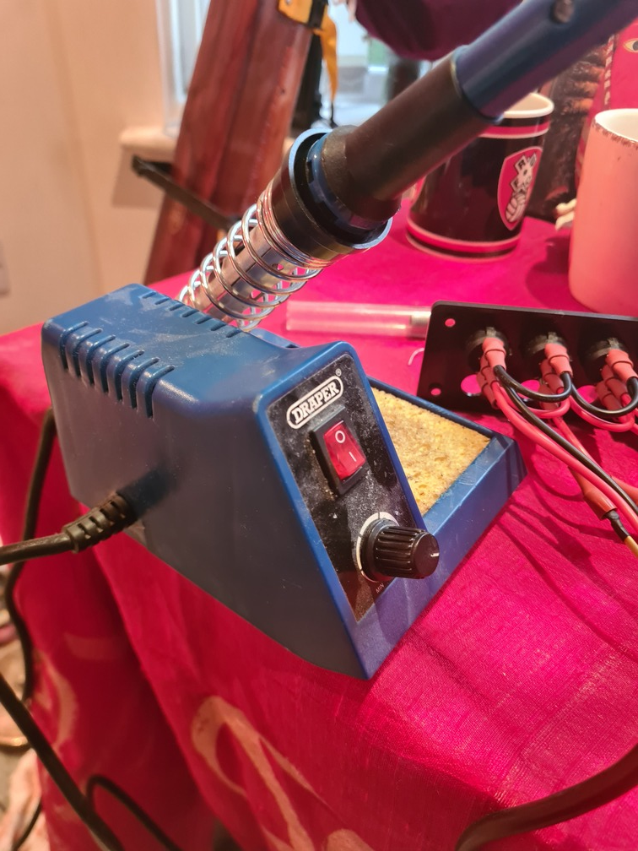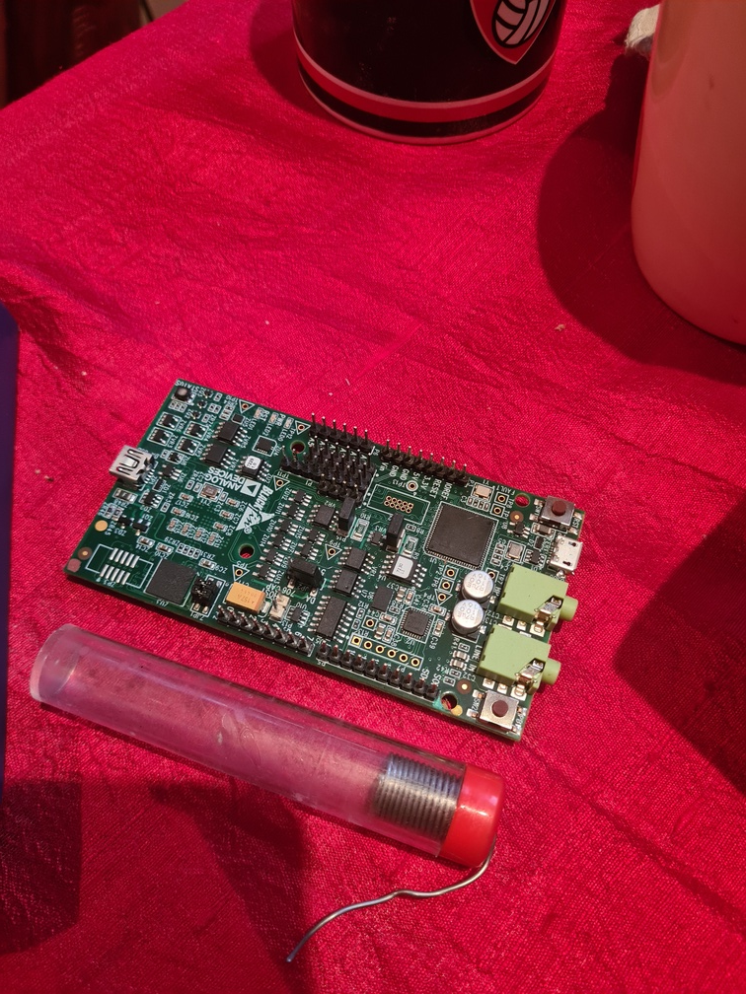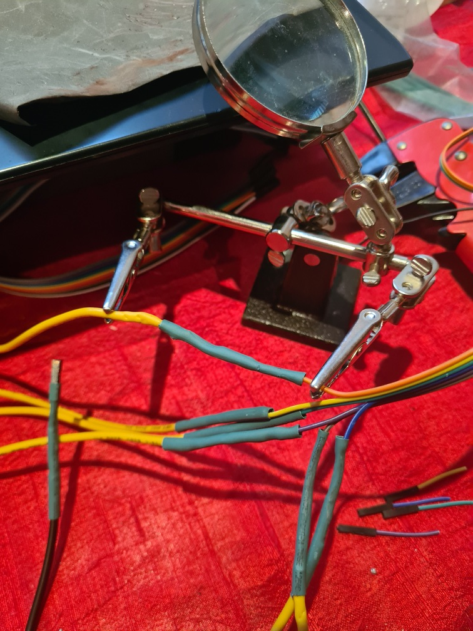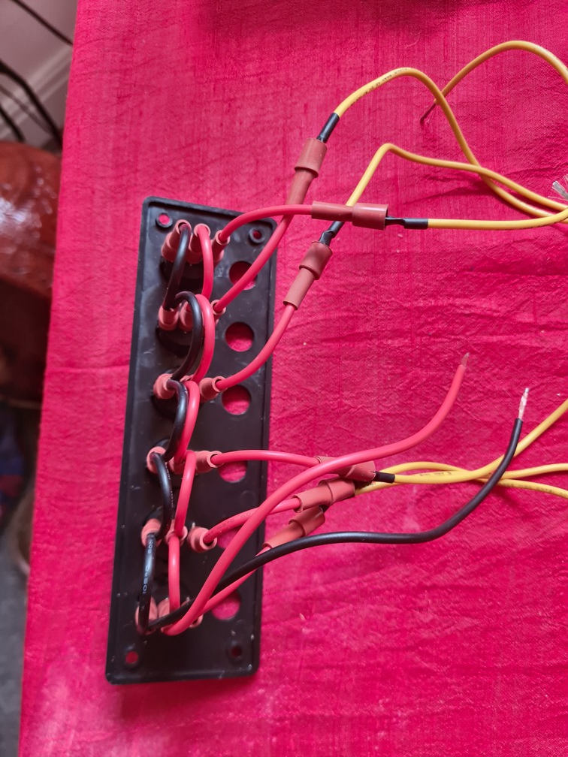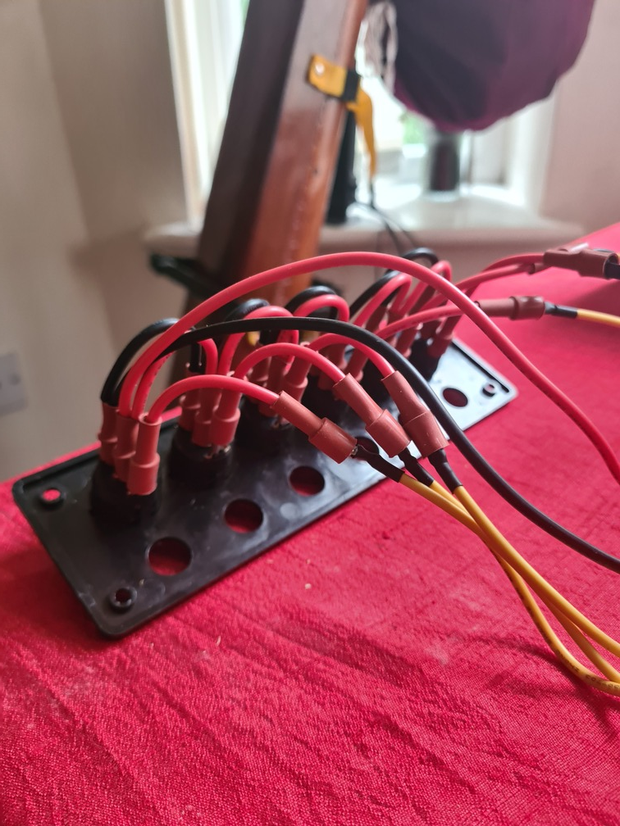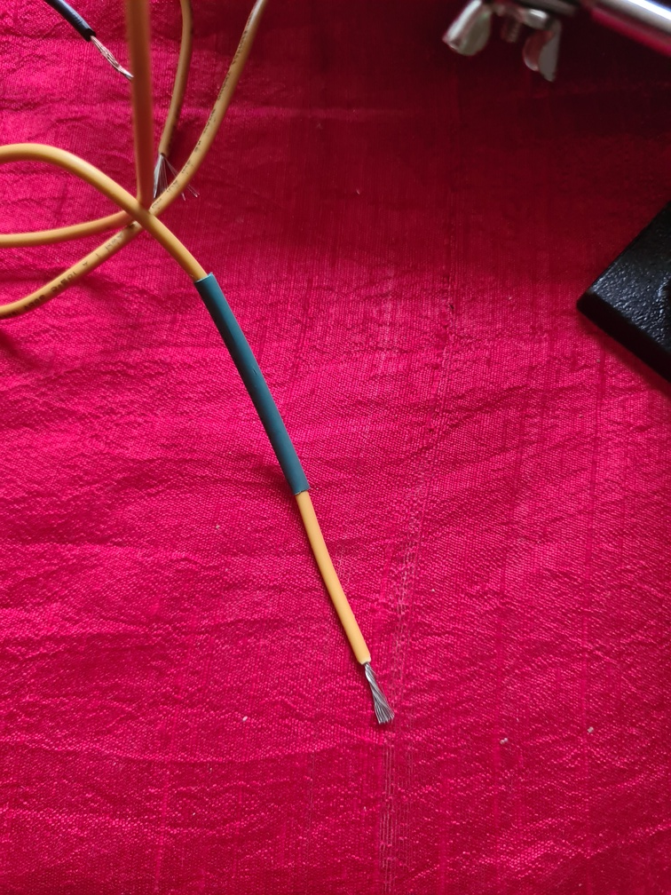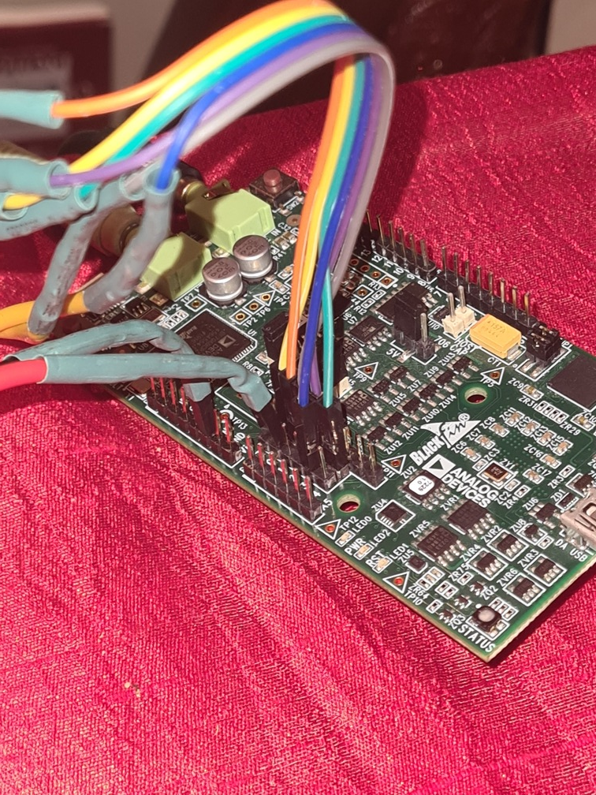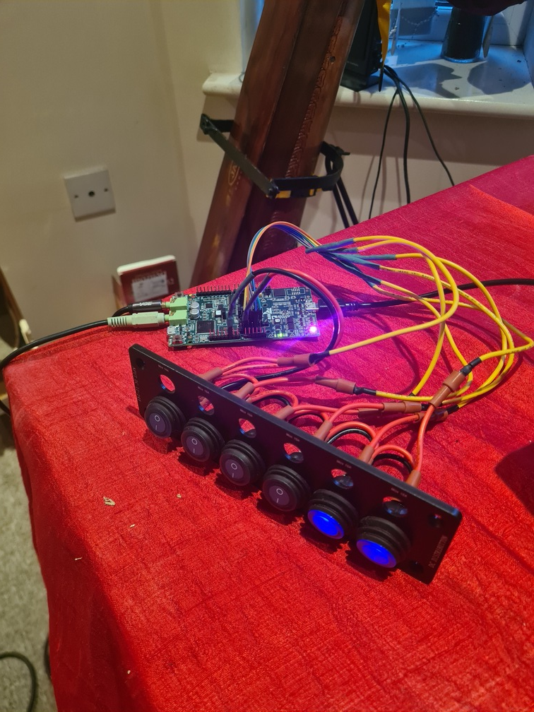

## Appendix 6 – Housing ConstructionA picture containing indoor, floor, red Description automatically generatedA picture containing red, indoor Description automatically generatedA picture containing text, indoor, items Description automatically generatedA picture containing person, indoor, hand Description automatically generatedA picture containing electronics Description automatically generatedA hand holding a circuit board Description automatically generated with low confidenceA picture containing person, holding, red, hand Description automatically generatedA picture containing person, hand, close Description automatically generatedA picture containing indoor, person, cluttered Description automatically generatedA picture containing indoor, cluttered Description automatically generatedA picture containing indoor, red Description automatically generatedA picture containing text, person, indoor, red Description automatically generatedA picture containing person Description automatically generated

## Appendix 7 – Finished Product Photos

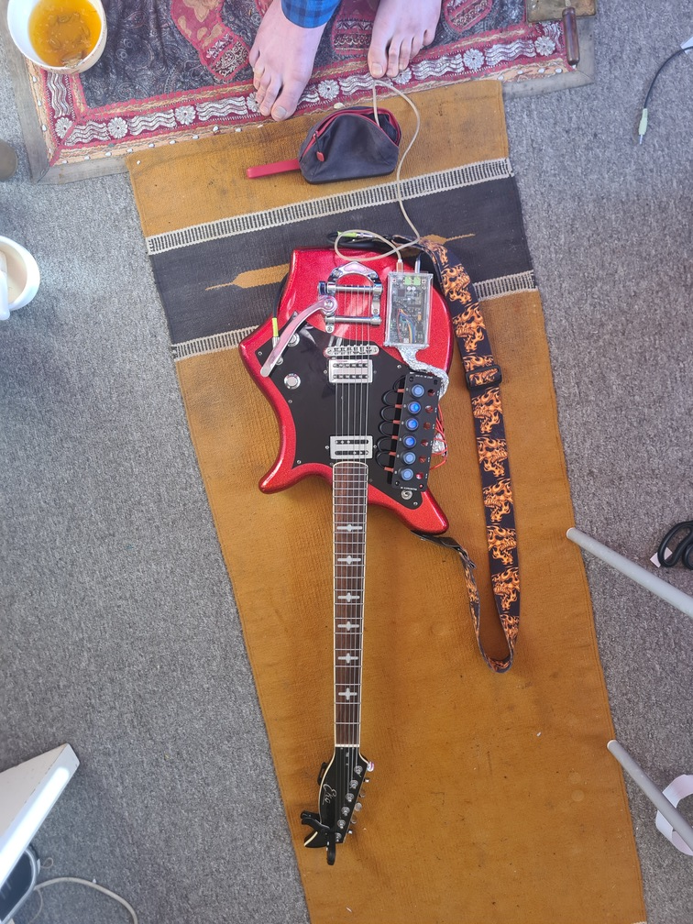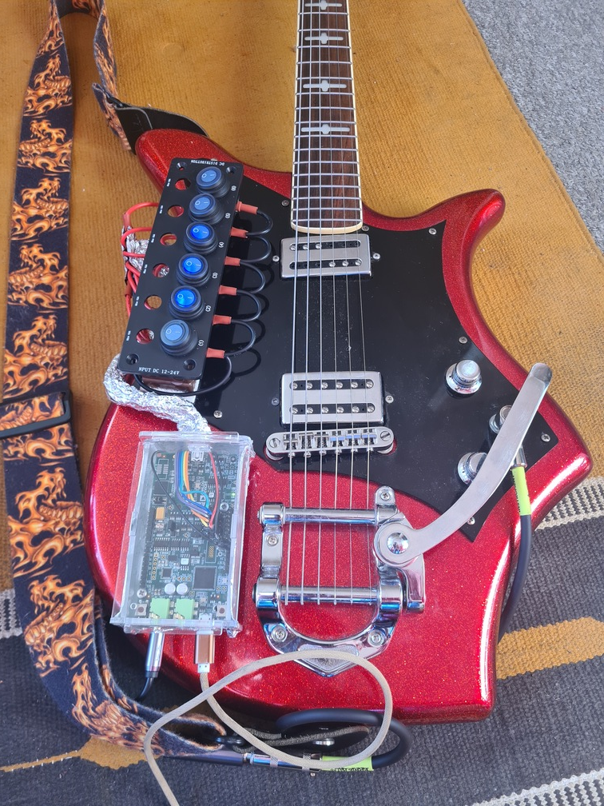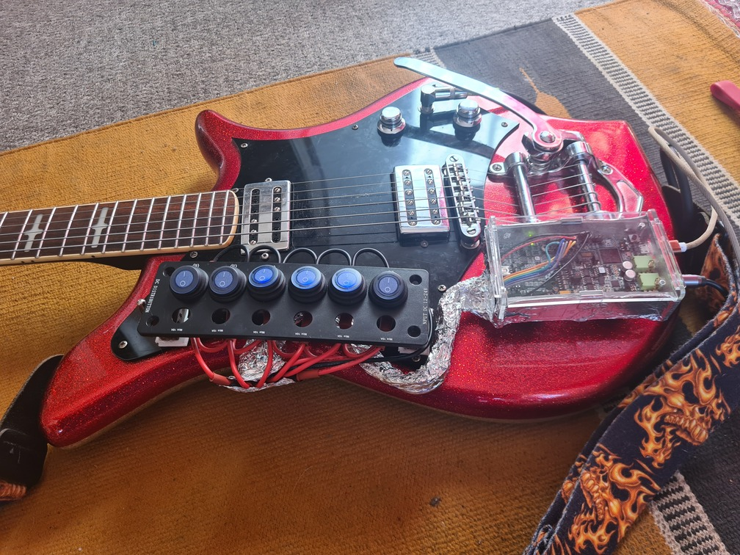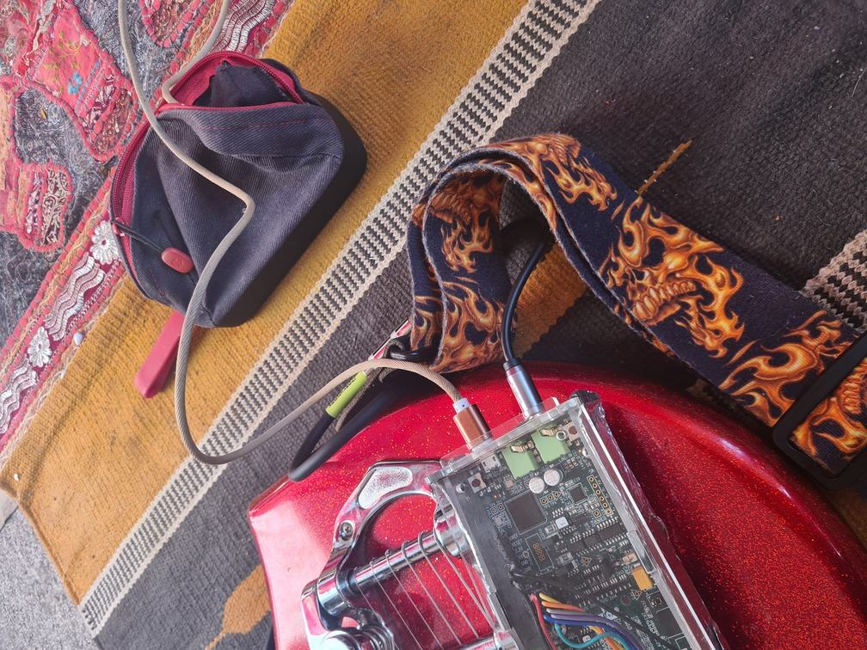

## Appendix 8 – Peer Review 3

### Jonathan

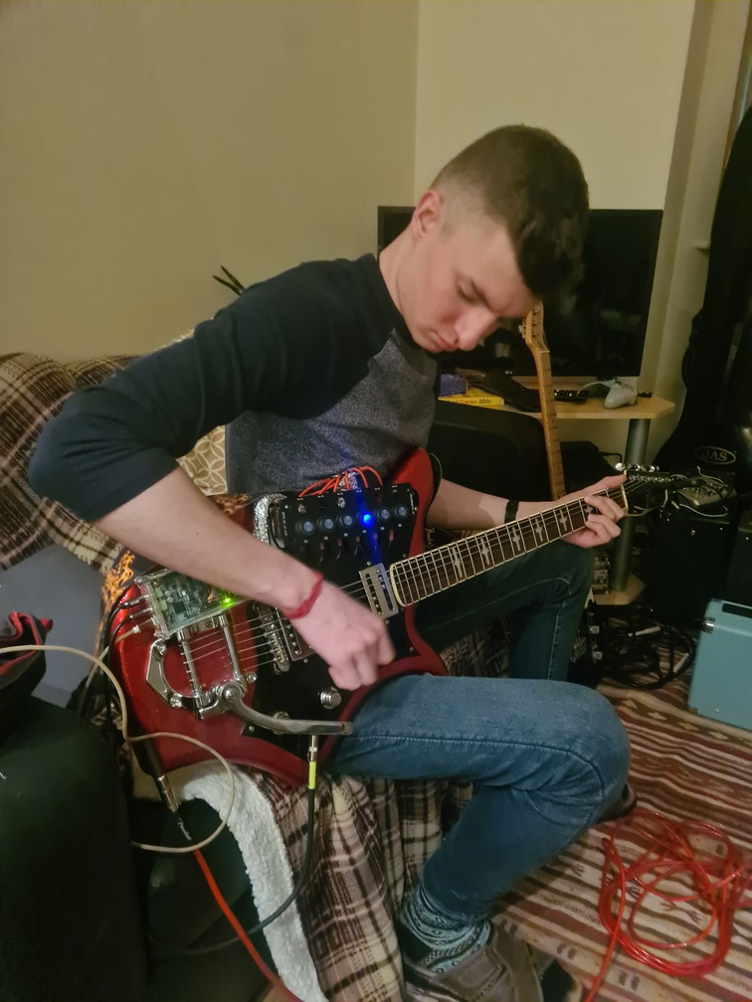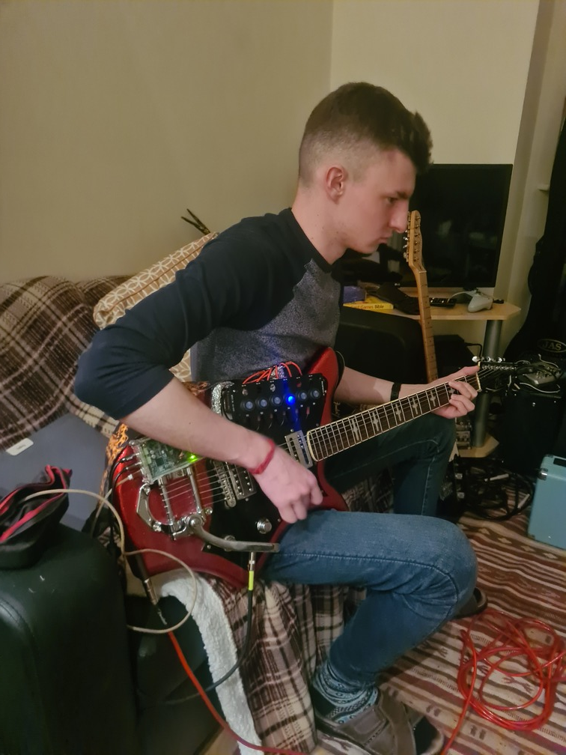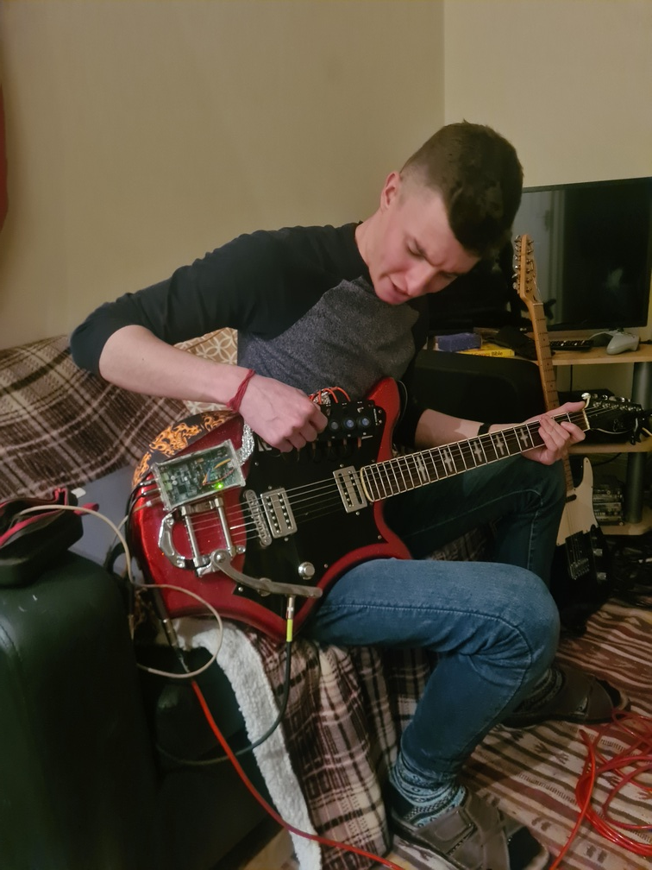

### Fraser

